**IMPLEMENTATION OF TASK AND SCHEDULE**

**MONITORING AND APPOINTMENT SYSTEM**

**IN THE MAYLAFLOR AIRCONDITIONING**

**AND REFRIGERATION SERVICES, INC.**

A Thesis Presented to the

School of Information Technology and Computer Studies

Polytechnic University of the Philippines

Taguig Branch

In Partial Fulfillment of the Requirements for the Degree of

Bachelor of Science in Information Technology

by

**Kristine Jilliane A. Aligato**

**Markrey B. Manabat**

**Joanna Allysa O. Padawang**

**Zahara Mae B. Sabasa**

**TABLE OF CONTENTS**

Page

**Copyright Page**

**Title Page……………………………………………………………………… ii**

**Certification and Approval Sheet…………………………………………. iii**

**Acknowledgement…………………………………………………………… iv**

**Certification of Originality……………………………………………….…. v**

**Abstract………………………………………………………………………... vi**

**Table of Contents……………………………………………………......…... vii**

**List of Tables…………………………………………………………………. viii**

**List of Figures………………………………………………………………… ix**

**Chapter 1: PROJECT DEFINITION**

1.1 Introduction……………………………………………………………. 1

1.2 Statement of the Problem……………………………………………

1.3 Theoretical Framework……………………………………………….

* 1. Task Management……………………………………………
  2. Technology Acceptance Model………………………….….

1.4 Conceptual Framework……………………………………………….

1.5 Project Assumptions………………………………………………….

1.6 Background Organization……………………………………………

* 1. Organizational Structure…………………………………….

1.7 Project Overview………………………………………………………

* 1. Objectives……………………………………………………...
  2. Scope and Limitations of the Study…………………………
  3. Significance of the Study………………………………........

1.8 Definitions of Terms…………………………………………………...

**Chapter 2: FUNCTIONAL SPECIFICATION REPORT**

2.1 Synthesis of the Reviewed Literature and Studies…………….….

2.2 Current IT Environment/Infrastructure….……………………….….

* 1. Hardware Specifications……………………………………...
  2. Software Specifications……………….……………...……….
  3. Network Specifications…………………………...…………
  4. Manpower……………….…………………………...…………
  5. Back-up and Recovery……………………………...…………

2.3 Data Requirements.……………………………………………………

* 1. Forms…………………………………………………………...
  2. Reports…………...………….………….……………...……….
  3. Logical Data Structure.………………………………………...

2.4 Policies and Procedure………………………………………………...

* 1. Procedures……………………………………………………...
  2. Policies…………...………….………….……………...……….

2.5 Problem Analysis……………………………………………………….

* 1. Fishbone Diagram……………...……………………………….
  2. Problem Requirements………………………………………….
  3. Requirements-Feature Matrix……………………………….….

**Chapter 3: PROPOSED SYSTEM DEFINITION**

3.1 Methodology……………………………………………………………

* 1. Research Design………………………………………………
  2. Sources of Data...………………………………………………
  3. Research Instrument………………………………………….
  4. Data Gathering Procedure……………………………………
  5. Ethical Considerations………………………………………...
  6. Proposed System Architecture……………………………….

3.2 Functional Specifications…………………………………...………….

* 1. System Boundaries…………………….……………………….
  2. System Prototype.……………………………………………...

3.3 Technical Specifications.……………………………………………….

* 1. Database Design……...…………………………………….….
  2. Screen Design………………………………………………….

3.4 System Requirements……………………………………………….….

* 1. Hardware/Software/Peopleware………………………………
  2. Security………………………………………………………….

**REFERENCES………………………………………………...…………….….**

**List of Tables**

Table 1. List of Forms

Table 2. List of Reports

Table 3. Problem Requirements

Table 4. Requirement-Feature Matrix

Table 5. Hardware/Software Requirements

**List of Figures**

Figure 1. Statement of the Problem

Figure 2. Technology Acceptance Model from Davis, Bagozzi et Warshaw (1989)

Figure 3. Conceptual Framework

Figure 4. Organizational Structure

Figure 5. Actual Sample of Monthly Preventive Maintenance Services Sheet

Figure 6. Actual Sample of Service Report

Figure 7. Entity Relationship Diagram

Figure 8. Context Diagram

Figure 9. Data Flow Diagram

Figure 10. Process Flow

Figure 11. Fishbone Diagram  
Figure 12. 5-point Liker Scale

Figure 13. Purposive Sampling

Figure 14. System Architecture Diagram

Figure 15. Use Case Diagram

Figure 16. System Flow

**Chapter 1**

**PROJECT DEFINITION**

* 1. **Introduction**

Manual recording of files may be quick, easy, and required at the beginning of a business. However, it may become a time-consuming and inconvenient habit as a company expands. And in today's fast-paced corporate environment, it's critical to file, retrieve, and quickly keep documents without the hassle of using loads of paper that are prone to lose and damage. With today's ever-evolving technology environment, we should make the most of it by utilizing it in any way that might assist us in relieving our responsibilities. And as the said information suggests, there are more effective ways to stay organized while increasing productivity with the help of technology. That's how the Task and Schedule Monitoring and Appointment System (TSMAS) was proposed for the use and betterment of Maylaflor Airconditioning and Refrigeration Services, Inc.

Maylaflor Airconditioning and Refrigeration Services, Inc. is a company that provides installation, maintenance, check-ups, filtration, and general cleaning of various air-conditioning units of their clients of more than 100 BDO branches. One big issue with the company is that they continue to utilize the traditional tracking and scheduling of their tasks and daily schedules. Their scheduling is done via phone calls. After their technician has examined the client's problem addressed during the call, the service that needs to be performed will be determined and arranged manually. A few great difficulties with the company's manual scheduling system are its lack of visibility, vulnerability to damage or loss, and time-consuming nature. They must repetitively schedule tasks on a specified date and time every month per branch, depending on the service required. But, with the utilization of the Task and Schedule Monitoring and Appointment System, quicker scheduling and schedule visibility while ensuring sufficient safety of their reports and data would be possible. This system will print reports, which some will be the basis of the company's invoice. It will also keep all schedules, customer information, the names of employees in charge of each job, and the tasks offered, and aid in the speedier summary of all completed and pending activities.

* 1. **Statement of the Problem**

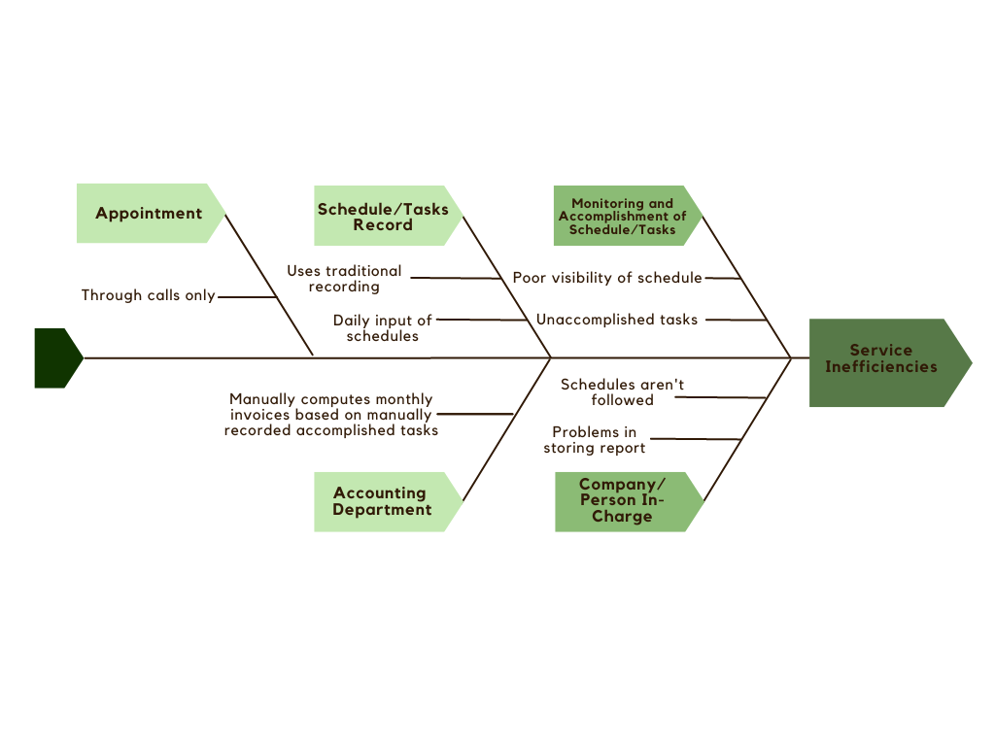The researchers aim to create and implement a more secure, organized, and accessible Task and Schedule Monitoring and Appointment System of the company. Below is a fishbone diagram containing the problems commonly encountered by the company using the traditional recording or scheduling.

*Figure 1. Statement of the Problem*

The following are the causes that result in service inefficiencies of Maylaflor Airconditioning and Refrigeration Service, Inc.:

* They continued to use traditional recording methods, which resulted in a damaged record that hampered their service. They also used daily written entry of schedules, which would be a lot of work because they need to attend to more than 100 clients in a month. If TSMAS is used, daily input will be reduced since the system will allow users to automatically schedule services on a set date each month per client.
* They have poor visibility of schedules as every schedule isn't organized. This visibility issue also causes hassle in the accomplishment of their target tasks/services.
* The Accounting Department suffers from manually computing every service done per month in every branch.
* The person-in-charge suffer great cause as the company would be compromised if all needed records aren't stored properly, and schedules aren't followed. It would cause to loss of clients' trust.
* The appointments are catered to through calls only.
  1. **Theoretical Framework**
  2. **Task Management**

Identifying and tracking the progress of the different tasks that make up a certain task strand, work package, or overall project is what task management is all about. As a result, the jobs can range in size from a few hundred to thousands. However, one constant in task management philosophy is the emphasis on clear information and how it may assist you and your team in achieving success (“What is Task Management Theory? & How it Impacts the Overall Project,” 2020). There are many various perspectives on the best ways to handle tasks, as well as a lot of wonderful online project management tools that can make task management an easy and straightforward procedure. The way an individual or project manager approaches task management theory is critical because it is a set of guidelines that determines how efficient and productive their task management is, which has a significant impact on how well project goals, milestones, and deadlines are met.

**1.3.2 Technology Acceptance Model**

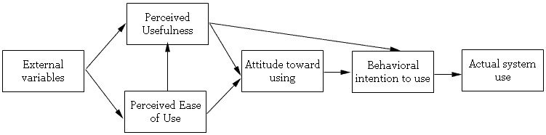Davis (1986) established the Technology Acceptance Model, which is based on the theory of reasoned action and deals with the prediction of an information system's acceptability. The goal of this model is to anticipate a tool's acceptance and to indicate the changes that must be made to the system in order for it to be acceptable to users. According to this approach, an information system's acceptability is defined by two key factors: perceived usefulness and perceived ease of use (“Technology acceptance model - EduTech Wiki,” 2019). The degree to which a person believes that using a system will improve his performance is characterized as perceived usefulness. The degree to which a person believes that using a system will be simple is referred to as perceived ease of use. Perceived usefulness and perceived ease of use were found to be two distinct aspects in several factorial analyses (Hauser et Shugan, 1980; Larcker et Lessig, 1980; Swanson, 1987).

*Figure 2. Technology Acceptance Model from Davis, Bagozzi et Warshaw (1989)*

* 1. **Conceptual Framework**

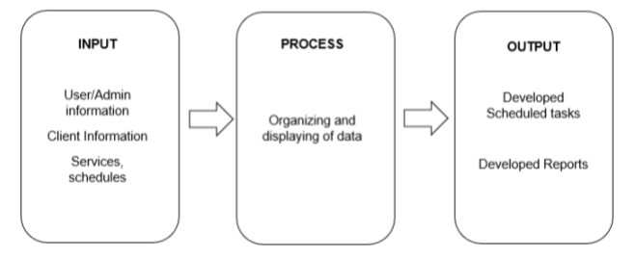The study is based on the Input-Process-Output (IPO) model for the design and creation of the Maylaflor Airconditioning and Refrigeration Services, Inc. Task and Schedule Monitoring and Appointment System that enables users to access, process, produce and save data in a database using a user-friendly interface.

*Figure 3. Conceptual Framework*

* 1. **Project Assumptions**

**Project Name:**

MARSI: Task and Schedule Monitoring and Appointment System

**Project Definition:**

This system facilitates effective and efficient tracking of all tasks, schedules, appointments, and data to be more organized and systematic regarding the application of their services. This is intended to replace the manual process of the company in assisting clients that want to get their services and to reduce the time spent in generating reports.

* 1. **Background of the Organization**
  2. **Organizational Structure**
  3. **Project Overview**
  4. **Objectives**

The Maylaflor Airconditioning and Refrigeration Services, Inc. Task and Schedule Monitoring and Appointment System is designed to monitor the customer's appointments, as well as the company’s task and service schedule, by replacing the manual process which uses paper work that consumes a lot of time. It encompasses service availability, as well as a scheduling system that keeps track of the day and time when the services must be completed, as well as a general overview of the company's activity. The interface will be made to have a friendly look to make the user feel more comfortable navigating and viewing the data on the system.

**General Objectives**

The system aims to provide a more useful and efficient approach for the company that will save time, lessen the amount of labor, and replace the manual method in order to more effectively manage the appointments, tasks, and schedule of services.

**Specific Objectives**

The company services a large number of clients, through the manual process that the company currently utilizes would result in the wasteful usage of paper and would also make it easy for data to be damaged or lost. The following are the specific objective(s) why the system should be implemented:

* + To be able to change the traditional process of filling up the forms in order to avail the services into computer-based forms.
  + To accommodate the customers who want to avail the services that the company is offering in an organized and systematic way.
  + To allow administrator and the other users to easily track appointments and schedules.
  + To improve and prioritize data management and protection for better tracking, storing, and organizing appointments, tasks and schedules/reschedules of services.
  + To easily generate reports of summary such as services, customer information, payments, aircons, etc.
  1. **Scope and Limitations of the Study**

**Project Scope:**

**Task and Schedule Monitoring System**

The Task and Schedule Monitoring System manage the company's schedules and tasks. This part is accessible to system administrators in charge of scheduling tasks provided by clients via phone conversations, confirming or declining appointments created by the clients through the Appointment System, and ensuring that all schedules are done on time. Employees of the company are also granted access here, where they may monitor any tasks allocated to and completed by them, as well as their schedules.

**Appointment System**

The Appointment System is designed to allow clients to schedule appointments online rather than over the phone. It will enable customers to select their chosen date and services and input all necessary information. It will also notify them if the system administrators confirm or deny their appointment. Aside from that, this system allows them to see the status of their confirmed appointments.

**Project Limitation:**

The MARSI: Task and Schedule Monitoring and Appointment System (MARSI: TSMAS) is the proposed system of the researchers that is only available for the use of Maylaflor Air-Conditioning and Refrigeration Services, Inc.'s admins, employees, and BDO or non-BDO clients.

The accounts of the employees will be created by the admins to make sure that account duplication and unauthorized access will not occur. Also, the BDO clients are allowed to create an account, but only once. For their accounts to be confirmed, the code they will input during their account registration should match the unique code provided to them. It is to ensure the legitimacy of their accounts and avoid future problems as they are contracted clients of the company. On the other hand, non-BDO clients can register their accounts without using codes and waiting for confirmation. The researchers have set these limitations to make the research more specific and accurate.

**Tools:**

The said project doesn’t cover the hosting cost and the device that the system will use for the implementation.

* 1. **Significance of the Study**

The study's findings will merit the following:

* Company - This will be a way to address the issue of manual checking/tracking of logs generated by the services that they supply. It boosts the efficiency of the company's service. Moreover, this also could prevent data loss and increases service production.
* Future Researchers - This study can be used as a reference for businesses looking to innovate in accordance with service production.

**1.8 Definition of Terms**

**Data.** This refers to the information processed or stored by a computer. This information may be in the form of text documents, images, audio clips, software programs, or other types of data.

**Database**. This refers to the information that is set up for easy access, management, and updating. Computer databases typically store aggregations of data records or files that contain information, such as sales transactions, customer data, financials and product information.

**System.** This is the hardware, software, data, databases, data communication lines, network and telecommunications equipment, Internet-related information technology infrastructure, wide area network, and other information technology equipment, owned, leased or licensed by seller or any of its affiliates and used in the Business.

**Web-based.** This is relating to or done using the Web (the system of connected documents on the internet).

**Chapter 2**

**FUNCTIONAL SPECIFICATION REPORT**

**2.1 Review of Related Literature and Studies**

In times of significant need for the quick completion of duties and the clearing of schedules, we come up with ideas that might make our regular activities a lot more convenient. This convenience is primarily recognized as the deployment of technology or a system. These systems might be created or deployed for thousands of people, particularly for businesses that demand a high volume of tasks. Task and Schedule Management Systems are examples of systems used to make it easier to complete tasks and schedules. With the introduction of the following, we can notice a significant improvement in how the persons in charge manage the logs present.

**Optimization, Innovation, and Automation**

Scientific & Technological task management innovation occurred with several characteristics; each country's innovations are related to each other to create a certain synchronism. Innovation does not occur in all aspects of S&T but focuses on a number of aspects that may change the management system. The overall goal of innovation is to improve the efficiency of S & T management (Hoang Lan Chi & Thu, 2017).

This article introduces a platform for intelligent task management. Depending on the present health care context documented in a continuous care ontology, automatically prioritizes and (re-) assigns tasks to the relevant careers (Intelligent task management platform for health care workers, 2017). How to plan the most appropriate travel schedule under simultaneously considering several factors such as tourist attractions visiting, local hotels selecting, and travel budget calculation is a challenge. Chiang & Huang (2015) develop a personalized travel planning system that simultaneously considers all categories of user requirements and provides users with a travel schedule planning service that approximates automation.

A department manager can effectively share and update pertinent data with employees via a unified system. Managers can specify the daily timetable and associated tasks through an integrated cloud-based web calendar. As a result, the manager can optimize the communication with employees of day-to-day operations (Hughes, 2018).

**Integrated System**

This system has been demonstrated to be an excellent method for developing stable project schedules, including a helpful control tool for dealing with schedule unpredictability. With the deployment of this system, crucial information regarding the relative activity criticality of the projects may be highlighted to management. This study also discusses how good schedule tracking may aid in readily monitoring schedule breaches and responding fast by taking action (Hu, Cui, Demeulemeester & Bie, 2016).

Scheduler+ is a GIS-based integrated scheduling system for planning, managing, and supervising field staff. Its goals are to guarantee dynamic and automated scheduling of client point-based tasks. Smart scheduling and planning information systems can assist in planning and organizing things at work (Köse, Çakici, Coskun, Kaymakçi, İşlek & Alsadi̇, 2021).

Keeping track of traditional records, gathering information, and keeping the data security takes more time and physical space. As mentioned by Chaudhari, Magar, Patil and Ubale (2020), a manual method causes problems in the business, whereas an integrated system reduces paperwork. As a result, any manual system has a variety of implicit issues. When errors occur, revisions are necessary, a manual transaction must commonly be rewritten rather than merely updated. Data must often be written down, duplicated, or entered multiple times in manual or partially automated systems.

**Real-Time Scheduling**

The purpose of this study is to demonstrate how entropy can be used in real-time scheduling and introduce it as a new parameter that researchers in many real-time systems domains may utilize. To reduce the uncertainty in the scheduling problem, completing the work with the highest entropy first and without missing any deadlines is prioritized in entropy. The likelihood of concluding a job during the hyper-period is the basis for calculating uncertainty (Rincon & Cheng, 2015).

**Schedule Management**

To analyze the basic functions of the schedule management software, and proposes the design and improvement of the intelligent management personal schedule system for its single and inefficient schedule management method. At present, the scheduling method is through the intelligent statistics and analysis of the user schedule, pushes scientific and reasonable scheduling schemes and suggestions to the user, and achieves the purpose of helping the user to effectively improve the life and work efficiency (Jiakai, Wen, & Gang, 2019).

Excessive cross-training can lead to a logistical challenge in that technicians are unsure of how to prioritize tasks. To overcome this, we identified and implemented three key tools to streamline operations. These include a dynamic depth chart, a self-schedule portal, and a laboratory information management system (LIMS) (“Improving Laboratory Workflow through Utilization of a Schedule Free System - ProQuest,” 2018).

Employee shift schedules can be managed with a scheduling software to reduce expenses and increase productivity. It revealed that optimal scheduling affects the duration of a job, the competence of employees, and the problems of increasing work scheduling targets based on marketing employee skills by optimizing operating time while providing quality services to clients. Overstaffing and understaffing are no longer a problem due to well-organized scheduling. An efficient type of software keeps track of and uses past data for each employee. It enables a successful management of the workforce by adding or removing employees as necessary (Rahardja, Andriyani, & Triyono, 2020).

Given the increase in the number of students and classes each academic year at the Multimedia Nusantara University (UMN) campus, this article offers a scheduling system designed to save work time and achieve space utilization rates each semester. It is accomplished by transforming formerly manual work into a web-based, integrated scheduling system for all parties involved (Forturia, Natu Prihanto, & Winarno, 2021).

**Task Management**

Task is an action that requires to be accomplished within a distinct period of to work towards goals. It may be in the form of assignments which should also have a defined start and end date or a deadline for completion. Completion of all assignments on a specific task ultimately renders the entire task completed. In this project, existing Task management systems are studied. The components those are required for implementing such system is discussed (Mahmud, 2018).

The Revit and Wrike task manager are a corporate online service for collaboration and project management. It allows users to plan projects, prioritize tasks, track the schedule of their implementation and interact with the team. The algorithm for calculating time by tasks was developed in the Dynamo environment using the Python language (Stepanova & Shilova, 2020).

The appraisal of employee performance is one of the most requirements for the successful running of higher educational institutions. In this article, we've created an automated task management system that may help higher education organizations (such as universities) evaluate an employee's performance (whether faculty member or staff). Based on the quantity of assigned work, completed tasks, and late or incomplete assignments, the system supports managers in assessing or identifying faculty members or staff, employees, and colleges. In addition, it will help to reduce the cost, time, and effort necessary to save critical information (Osman & Osman, 2019).

Product service systems (PSS), which increase value by combining physical items with services, have received a lot of attention in the manufacturing business. Study presents a task management system that allows manufacturers to create a variety of PSS choices. Typical product-selling manufacturers rarely offer PSS possibilities, study finds. The proposed framework offers designers perspectives and checklists for PSS design. An example case is used to demonstrate the framework's usefulness (“A Task Management Method for Product Service Systems Design | Muto, Keita; Kimita, Koji; Tanaka, Hiroki; Numata, Eriko; Hosono, Shigeru; Izukura, Sayaka; Shimomura, Yoshiki | Download,” 2016).

Task-oriented project managers keep a detailed and up-to-date project schedule, and a good team directs members and advances the project. The bulk of task management systems are incapable of capturing the attention and interest of their users. Gamification will be added to the task management system to make work management more structured, entertaining, and enjoyable. Levels, challenges, and prizes are examples of game mechanics that can help gamified system users achieve their goals (Moh Sukron Mufaqih, Kaburuan, & Wang, 2020).

TASKA, a task/workflow management system created as a modular web platform to ease study execution, team coordination, task scheduling, and researcher cooperation, is presented in this paper. The key functions of this system will be presented in the following sections, with an emphasis on the end-user perspective. To demonstrate its use, we offer a use case that tries to estimate the prevalence and incidence of acute myocardial infarction in a collection of disparate observational health data sources. The system was created as part of the European Medical Information Framework (EMIF), a European project aiI/med at creating an uniform technological and governance framework to allow health data sharing (Almeida, Gini, Roberto, Rijnbeek, & Oliveira, 2019).

**Cloud Computing**

In larger organizations with multiple tasks to execute at the same time, it is essential to keep track of all statuses to know how things are going. As mentioned by Arunarani et al. (2019), cloud computing is one of the most widely utilized technologies in recent years, allowing users to access computing resources as services over the Internet. The user in the cloud may use thousands of virtualized assets, and this will help them organize and manage the tasks to reduce time waste and optimize performance.

**Greater Overall Productivity**

Task management that is effective can improve performance and reduce stress, resulting in increased overall productivity and academic success. Using an AHP-based task management system not only makes complicated activities appear easier and more convenient, but it also helps the business meet deadlines and become more effective and efficient (Meitarice, Mustafa & Andi, 2021).

The following pieces of literature primarily focus on how task and schedule management systems aided in the easier utilization and storage of required data. They also demonstrated how heavy workloads were continually lowered when the tasks at hand were given adequate prior attention with the assistance of the aforementioned methods. However, these systems still require refinement since some issues may exist, such as a lack of backup data, which may result in the eventual loss of all data if human faults occur while operating the system. It also requires a thorough examination before the deployment of the current study. The associated works of literature should serve as a foundation and an eye-opener in identifying holes that, if ever, could be filled.

**Technology**

In this research, several technologies can be employed to construct an information system or a system that will cater to the tasks and schedules of a company. There are several programming languages, frameworks, and database servers to choose from, but the ideal one to employ relies on the desired information system to be constructed, as well as the developer's experience and talents.

**Programming Language.**

PHP (Hypertext Preprocessor) is a popular open-source general-purpose scripting language that can be embedded in HTML and is well-suited for web development. PHP is platform-agnostic, which means it runs on all systems, including Mac, Windows, and Linux. PHP provides a library of PHP code that may be used to do typical tasks like database abstraction and error handling. According to Tatroe and McIntyre (2020), PHP is versatile in that it can create any document format other than HTML or text files. PHP includes the ability to generate PDF files as well as GIF, JPEG, and PNG pictures. PHP is capable of easily connecting to any database, relational or non-relational.

**Framework.**

The selection of a framework is essential since it affects the pace and quality of the work. To begin with, there are multiple benefits in which frameworks promote programming productivity by allowing to write a piece of code that would normally take hours and hundreds of lines of code in minutes using framework built-in functions. Second, a widely used framework has a significant security advantage. Third, many popular frameworks are free, and because they help developers produce code faster, the overall cost is cheaper. Finally, most frameworks provide a support team, documentation, or large support forums where users can get quick responses (Prokofyeva & Boltunova, 2017). PHP frameworks come in all forms and sizes, offering to developers of all levels of experience, application requirements, hosting capabilities, and production time (Benmoussa,

Laaziri, Khoulji, Larbi, & Yamami, 2019). One of these frameworks that can be used for the study is the CodeIgniter. According to Hustinawati, Himawan, and Latifah (2014), the CodeIgniter is an open-source web application framework for creating dynamic PHP applications. It is lighter and easier to acquire, modify, and integrate Library and Helper. Most developers prefer this framework because it involves less coding and includes extensive testing procedures that enable coders to create error-free, high-performance systems.

**Database Server.**

MySQL is the most dependable and widely used open-source database platform in use today. Because of its ubiquity across heterogeneous platforms and application stacks, as well as its well-known performance, stability, and ease of use, MySQL powers many of the world's most popular and heavily trafficked websites (Satoto et al., 2016). As studied by Letkowski, J. (2015), the major database systems (Oracle, MS SQL Server, DB/2, and so on) are supported by most database textbooks aimed at database design and implementation for information systems curricula. In terms of the most significant parts of database management, such as design and implementation, one should not overlook MySQL—the most extensively used, open-source, relational database management system developed in Sweden in 1995 and currently owned by Oracle Corporation.

To achieve proper management, a system that is supported by a database system is also required. This paper describes how to optimize a database system such that when data is accessed, it does not impair the performance of server systems. The database system's design is optimized for the process. The design of a database is critical in determining system performance (Satoto et al., 2016).

**Synthesis of Reviewed Literature and Studies**

The early studies conducted by the researchers solely focused on developing systems that help the companies to be organized, advanced, secured, and more flexible regarding their data. Defining, updating, distributing, enacting, monitoring, and assessing activities are still done by hand using a pen and paper, because of this there are tons of risks of losing the data and this is the main reason why the development of the system is a big factor to help them avoid these kinds of problems. For the Maylaflor Airconditioning and Refrigeration Services, Inc., the researcher considered developing a Tasks and Schedule Monitoring System that will allow the company to have a systematic way of recording, storing, and summarizing data. As a result, it will help the company to be more flexible regarding the handling of their data without worrying about security.

**2.2 Current IT Environment/Infrastructure**

Maylaflor Airconditioning and Refrigeration Services, Inc has been recording tasks and schedules manually, resulting in poor visibility of schedules because each schedule is not organized. When reports are required, it takes a long time and a significant amount of paperwork to complete them. Also, the individual responsible suffers the most because the company is put at risk if all necessary records are not properly stored and schedules are not followed. It also would affect clients' trust.

* 1. **Hardware Specifications**

Hardware specifications are currently unavailable because the company does not use any form of automation or computers and thereby records tasks and schedules manually.

* 1. **Software Specifications**

Since the company uses a manual process to record tasks and schedules and does not use any software tools or applications, there is no software requirements specification that can be provided.

* 1. **Network Specifications**

The network requirements specification is inaccessible due to the company's manual process of recording tasks and schedules.

* 1. **Manpower**

Maylaflor Airconditioning and Refrigeration Services, Inc personnel organize and track all tasks that have been scheduled, are being scheduled, and will be scheduled. It also keeps track of the data and compiles it for reporting purposes.

**End users:** Administrative Employee

* 1. **Back-up and Recovery**

The compiled records are kept in a folder and a cabinet. Employees must borrow the hardcopy and copy it using a xerox copy in order to provide a copy of those records, as there is no other backup. Since the company only has hard copies of those records, personnel are having difficulty recovering compiled records. Considering that the compiled records are still being recorded by hand with a pen and paper, they are prone to loss and damage.

The company is apprehensive to duplicate those records because they have an enormous amount of data acquired as a result of having more than 100 clients to accommodate, and doing so is very costly.

**2.3 Data Requirements**

This section shows the different forms and reports that are related to the proposed system. The list and description of forms and reports the researchers have gathered are shown here. The contents and data dictionary of these data requirements are also indicated.

* 1. **Forms**

|  |  |  |  |  |
| --- | --- | --- | --- | --- |
| LIST OF FORMS | | | | |
| **Figure** | **Name of Form** | **Description** | **Source** | **Receiver** |
| 1 | Monthly Preventive Maintenance Services Sheet | It contains the schedules and the services availed by all of the contracted clients of the company. | --- | --- |

**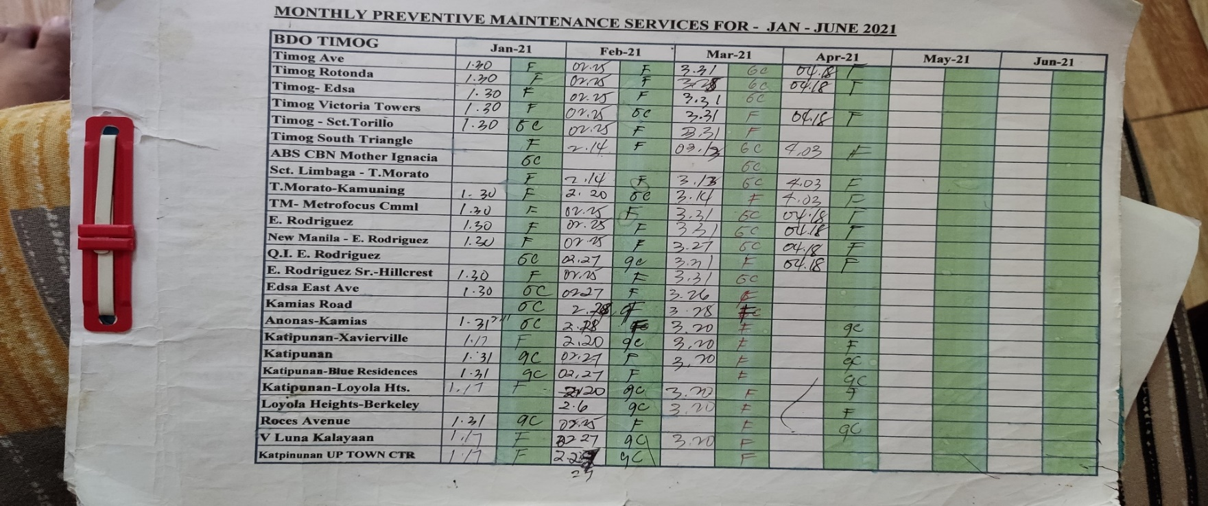***Table 1. List of Forms*

*Figure 5. Actual Sample of Monthly Preventive Maintenance Services Sheet*

* 1. **Reports**

|  |  |  |  |  |
| --- | --- | --- | --- | --- |
| LIST OF REPORTS | | | | |
| **Figure** | **Name of Report** | **Description** | **Source** | **Receiver** |
| 2 | Service Report | It contains all the necessary information about the service conducted by the company's service team. | Service Team (Employee of the Company) | Client |

*Table 2. List of Reports*

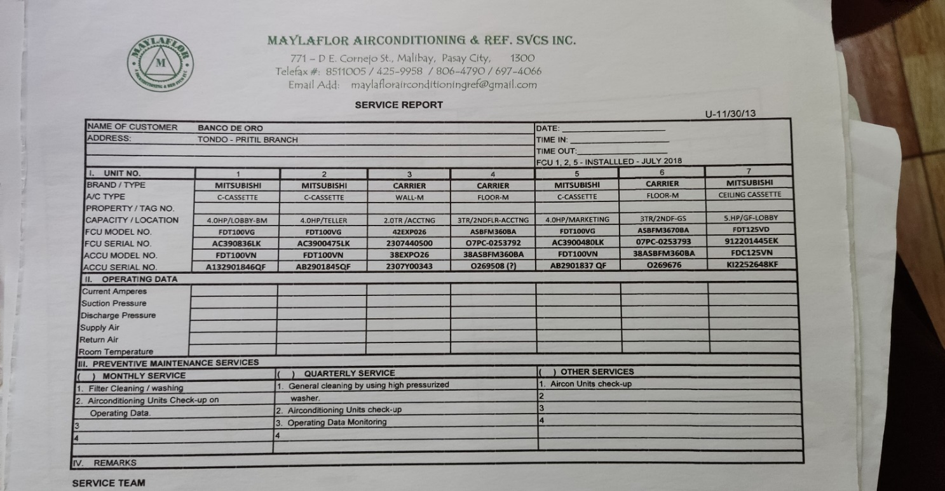*Figure 6. Actual Sample of Service Report*

* 1. **Logical Data Structure**

**Entity Relationship Diagram**

**2.4 Policies and Procedures**

This section contains procedure, policies, the context diagram, Data Flow Diagram, and Process Flow of the system.

* 1. **Procedures**

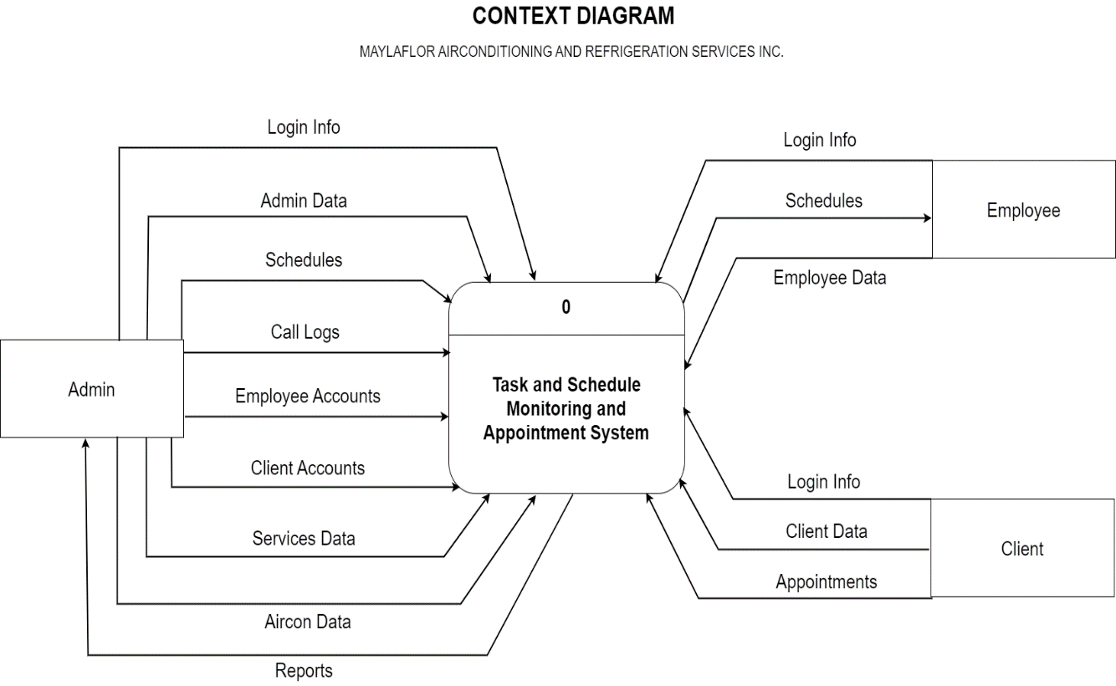**Context Diagram**

*Figure 8. Context Diagram*

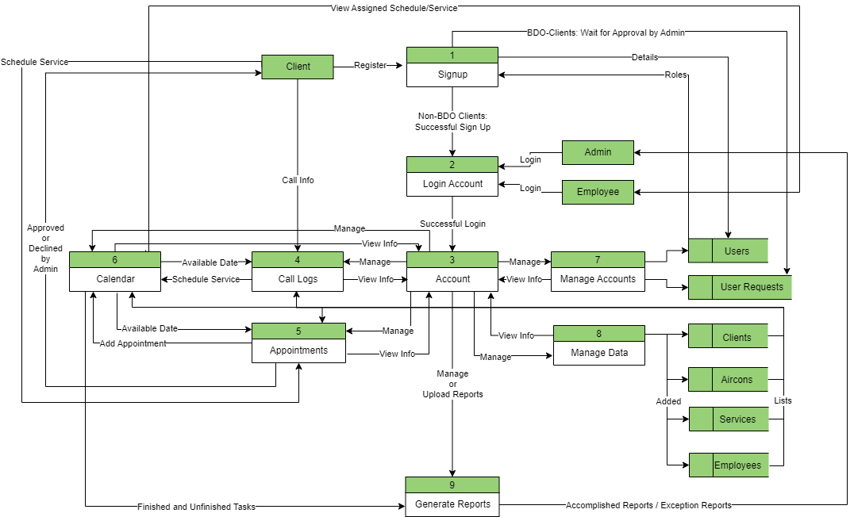**Data Flow Diagram**

*Figure 9. Data Flow Diagram*

**Process Flow**

Create and Log in Account for Admin, Employee, and Client

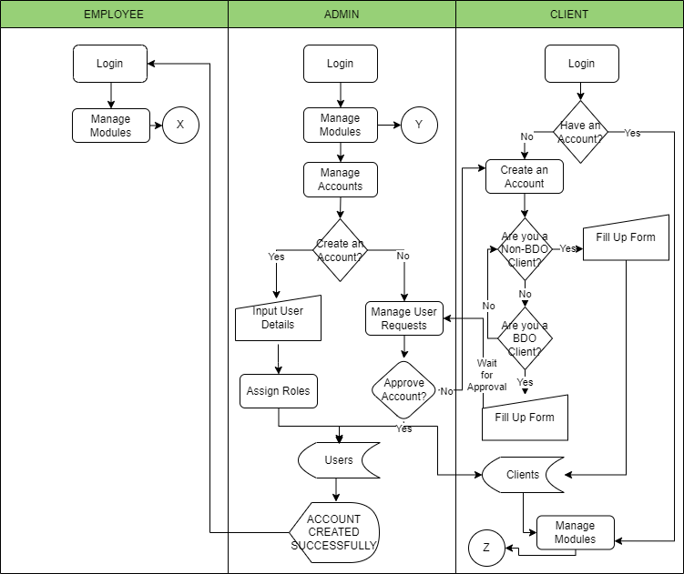

*Figure 10. Process Flow*

Manage Call Logs by Admin

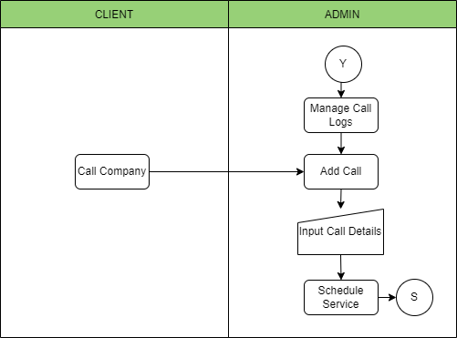*Figure 10.1. Process Flow*

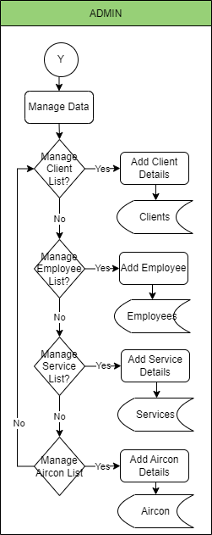Manage Data (Create Client, Employee, Service, and Aircon) by Admin

*Figure 10.2. Process Flow*

Create Schedule in Calendar

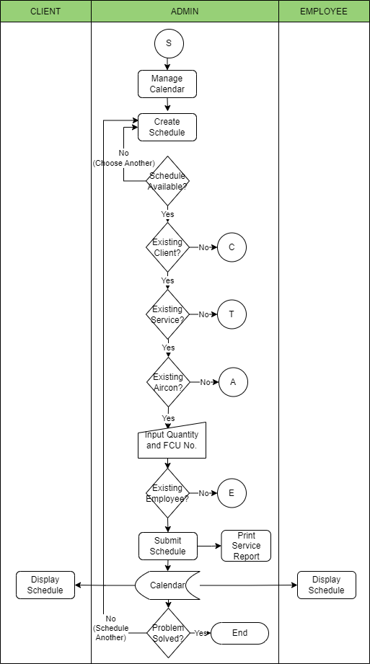

*Figure 10.3. Process Flow*

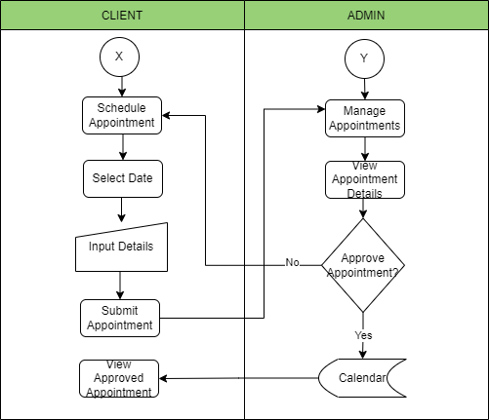Appointment System (Admin and Client)

*Figure 10.4. Process Flow*

Generate Reports (Admin)

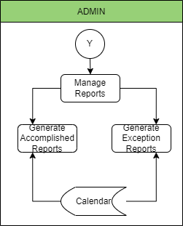

*Figure 10.5. Process Flow*

* 1. **Policies**

**Task and Schedule Monitoring**

* The tasks and schedules are written in manually printed forms (Monthly Preventive Maintenance Service Sheet). It contains the Client Branch, Date, Time, and Service.
* All of the forms are stored in a folder.

**Appointment System**

* The appointment system of the company is through calls. When the client calls, the employee handling the calls will gather information such as the Caller Name, Client Branch Name, Particulars, Device Brand and Type, and FCU Number.
* Once the service is scheduled, all details of the service will be written in a manually printed form called Service Report. There will be two copies of the Service Report in each service, one for the client and one for the company.

**2.5 Problem Analysis**

This section includes the Fishbone Diagram, Problem Requirements, Requirements-Feature Matrix and Conclusion and Recommendation.

* 1. **Fishbone Diagram**

*Figure 11. Fishbone Diagram*

The following are the causes that result in service inefficiencies of Maylaflor Airconditioning and Refrigeration Service, Inc.:

* They continued to use traditional recording methods, which resulted in a damaged record that hampered their service. They also used daily written entry of schedules, which would be a lot of work because they need to attend to more than 100 clients in a month. If TSMAS is used, daily input will be reduced since the system will allow users to automatically schedule services on a set date each month per client.
* They have poor visibility of schedules as every schedule isn't organized. This visibility issue also causes hassle in the accomplishment of their target tasks/services.
* The Accounting Department suffers from manually computing every service done per month in every branch.
* The person-in-charge suffer great cause as the company would be compromised if all needed records aren't stored properly, and schedules aren't followed. It would cause to loss of clients' trust.
* The appointments are catered to through calls only.
  1. **Problem Requirements**

|  |  |
| --- | --- |
| Problem | Requirements |
| Lost Records | **Secure Records**   * All tasks will be secured in the Calendar Module, including their details, such as the Date, Time, Branch Area (Client), Branch Name (Client), Service, Device Brand and Type, FCU No, Quantity, and Employee in charge. |
| Unfinished Tasks  Poor Visibility of Schedule | **Track the Tasks and Schedules**   * Monitor dates that are available and schedules that are already taken. |
| Unorganized Reports | **Generate Reports**   * Specific Time Frame |

*Table 3. Problem Requirements*

* 1. **Requirements-Feature Matrix**

**Chapter 3**

**METHODOLOGY**

**3.1 Methodology**

This presents the research methodology that includes the research design, sources of data, researchers’ instrument construction, data generation procedure, considerations in ethics, and the proposed system structure.

* 1. **Research Design**

The researchers employed Descriptive Quantitative Research methodology, which is a survey-type approach that allows them to collect the data essential for the system's deployment and development. Using this methodology, the researchers can keep track of the system's capabilities as well as its shortcomings, which will be used for future improvement. A survey study design is a technique in which researchers utilize a questionnaire to ascertain the users' experience and thoughts about the system. The quantitative data will be tallied and statistically evaluated to characterize the outcome.

* 1. **Sources of Data**

The study will be conducted on the company of the Maylaflor Airconditioning and Refrigeration Services, Inc. located at 2958 A. Dominguez St., Malibay, Pasay City. The company serves different branches of BDO around Metro Manila, where they will maintain and repair its air-conditioning and refrigeration demands.

* 1. **Research Instrument**

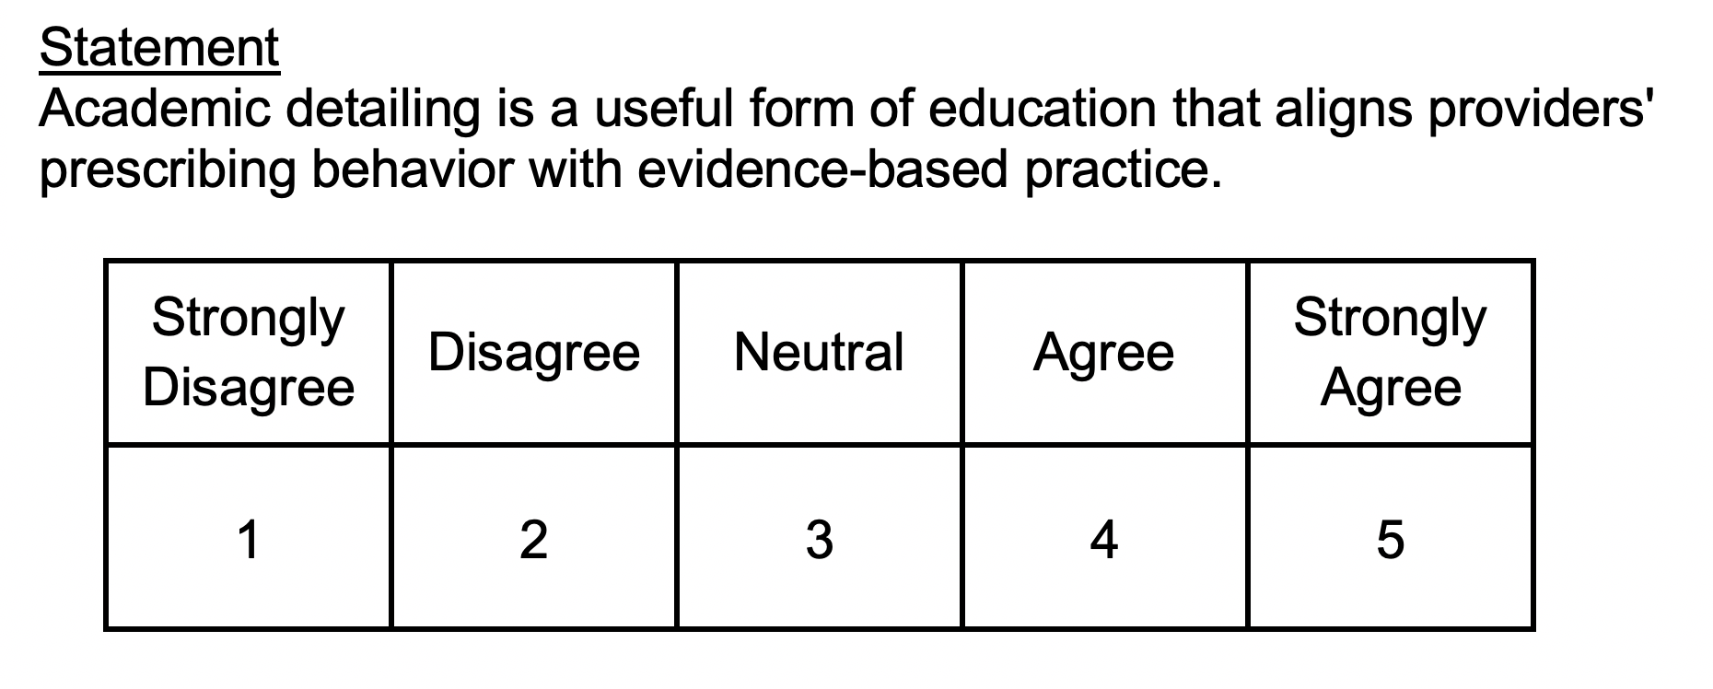The instrument used in constructing the online questionnaire is ISO 25010, a cornerstone of a product quality evaluation system that determines which quality characteristics will be taken into account when evaluating the properties of a software product. It comprises eight quality characteristics: Functional Suitability, Performance efficiency, Compatibility, Usability, Reliability, Security, Maintainability, and Portability. In order to collect quality data and get accurate responses, a 5-point Likert Scale is used to indicate the level of agreement or disagreement in a multiple-choice format.

*Figure 12. 5-point Likert Scale*

* 1. **Data Gathering Procedure**

The researchers will use an online survey questionnaire utilizing Google Forms to be disseminated to the research respondents. The study's respondents are the owners, employees, and clients of Maylaflor Airconditioning and Refrigeration Services, Inc. They are the only ones who have sufficient information to answer the questions given in the study. The questionnaire researchers supplied them should be completed by them, which will help provide the information researchers required.

The researchers used the non-probability sampling method, which is the Judgment or Purposive Sampling, also known as selective, or subjective, sampling. This technique relies on the researcher’s judgment on selecting respondents for their research.

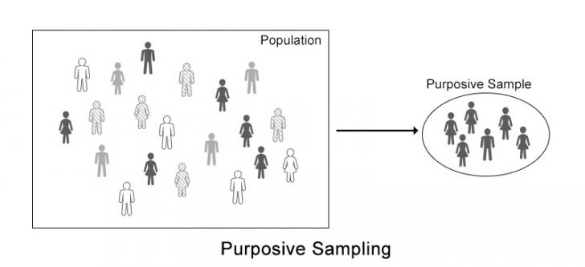*Figure 13. Purposive Sampling*

* 1. **Ethical Considerations**

Throughout the study, researchers are deliberate. Ethical considerations are supported, including informed consent provided by the client's confidentiality, and participants have been fully briefed at the conclusion of the study. These factors were considered in order to avoid as much harm as possible, regardless of the cause. The company provides the actual data acquired, which is strictly confidential in accordance with Republic Act No. 10173, also known as the Data Privacy Act.

The researchers have made certain that participation in this study is entirely voluntary and not mandatory. Participants have the option to decline at any time and are not required to answer all of the questions or follow any of the methods given.

* 1. **Proposed System Architecture**

The system architecture is an abstract representation of the component architecture of the system. It gives a concise description of the system's component architecture to help in component-component relationships and system operation (“System Architecture - Detailed Explanation,” 2022).

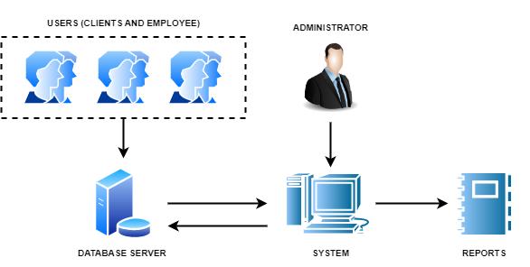*Figure 14. System Architecture Diagram*

The figure represents the administrator's interaction with the Task and Schedule Monitoring and Appointment System. The administrator will be in charge of managing the system via computer. The system will process the raw data stored in the database server to determine whether the required data is registered. If the credentials entered match the data stored in the database server, the users can now enter the system and gain privileges based on their role. Users with administrative privileges can also generate reports.

**3.2 Functional Specifications**

This section includes the system boundaries of the proposed system which are shown through use case diagram, detailed use case diagram, and the system flow.

* 1. **System Boundaries**

The Task and Schedule Monitoring and Appointment System will be used by the Maylaflor Airconditioning and Refrigeration Services, Inc. for tracking task and scheduled services and appointments monitoring based on the data and processes gathered by the group. This system would manage all of the company, BDO clients, and non-BDO clients' details and transactions. The use case diagram aided the developers in determining the system's specifications. It provides brief explanations of each subsystem's main functions as well as examples of how each subsystem interacts with one another and the other necessary transaction flow.

The system is divided into two: Task and Schedule Monitoring System and Appointment System. The Task and Schedule Monitoring System manage the company's schedules and tasks. The Appointment System is designed to allow clients to schedule appointments online rather than over the phone.

**Use Case Diagram**

**Detailed Use Case Diagram**

**System Flow**

* 1. **System Prototype**
* 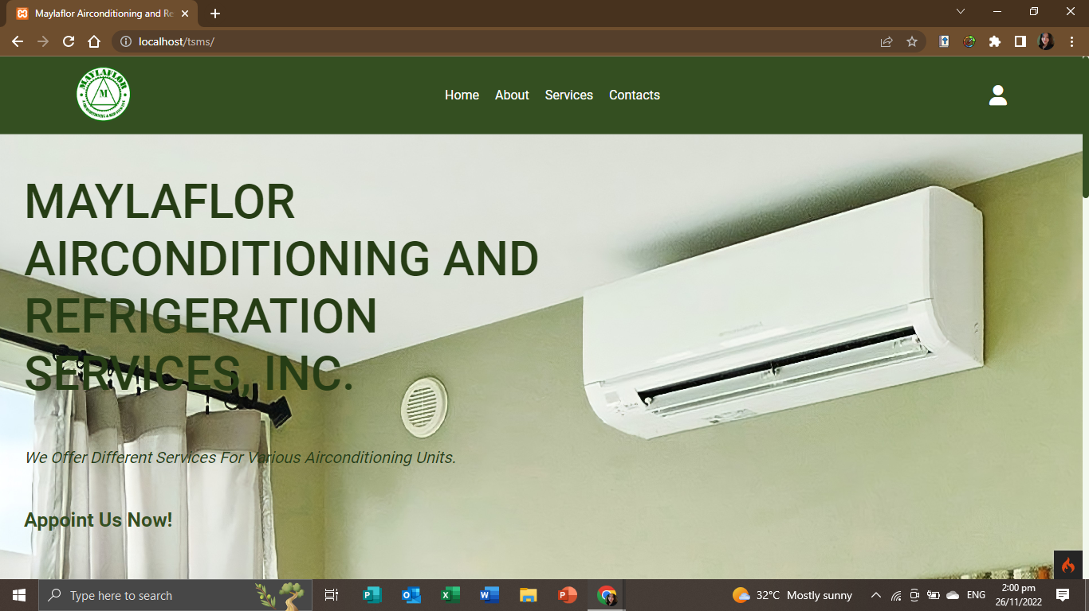**Homepage:** Allows the user to view the company, service offered, and contact details.
* 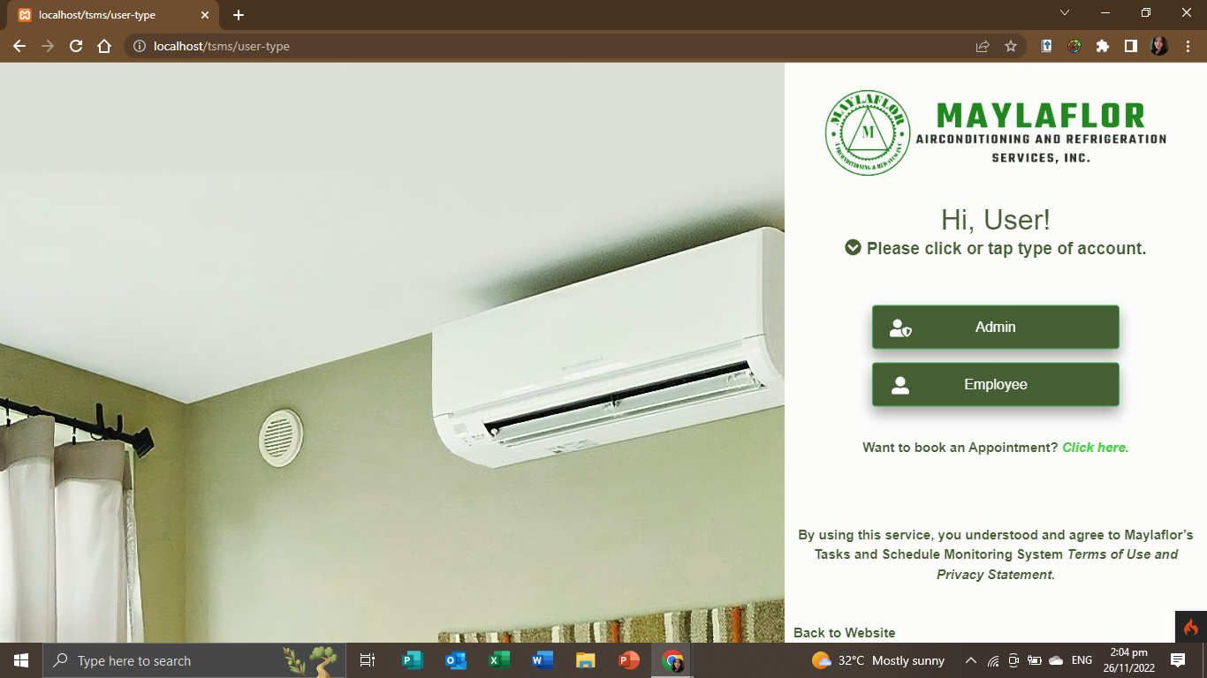**User-type page 1:** Allows the user to choose what type of account will login.
* 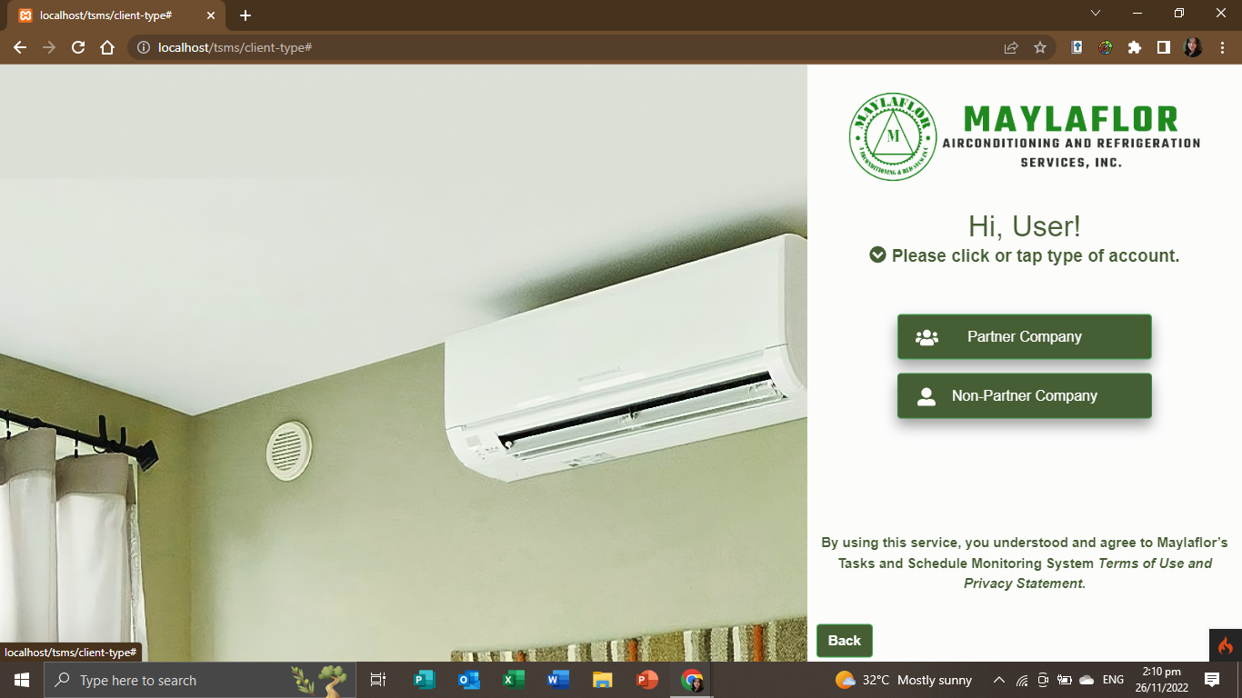**User-type page 2:** Allows the user to choose what type of account will login.
* **Login Page for Admin**

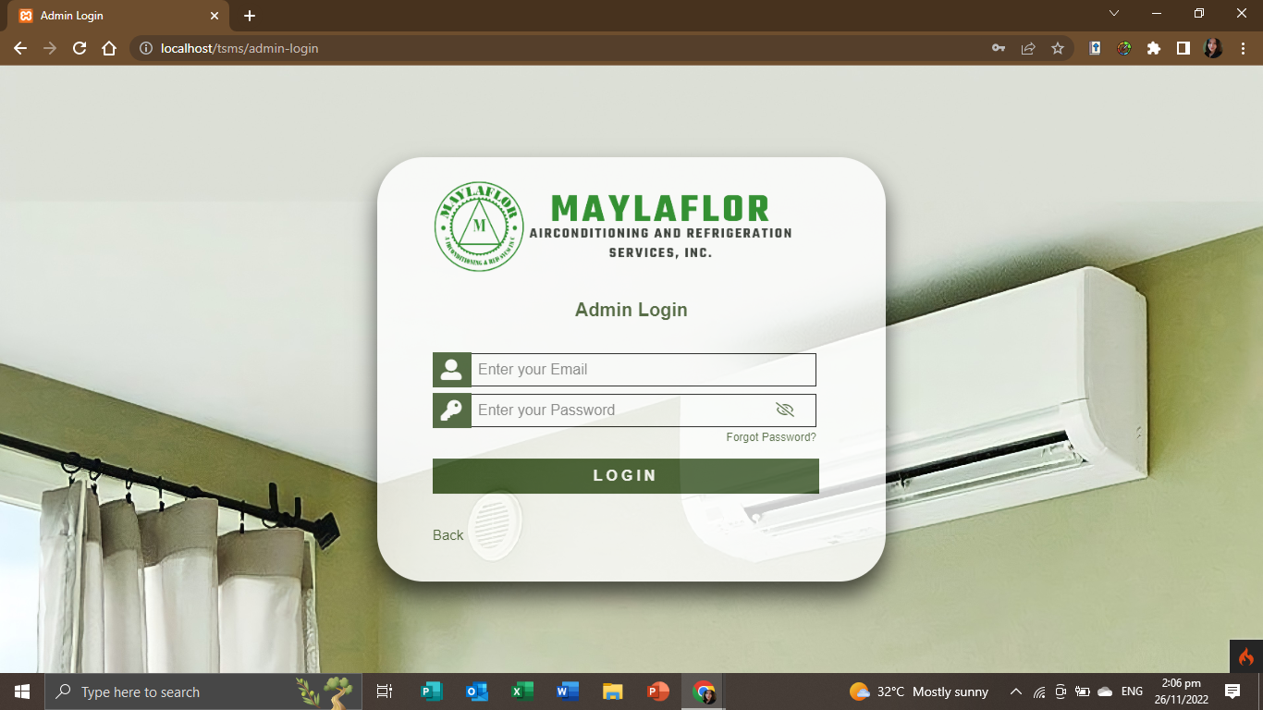

* 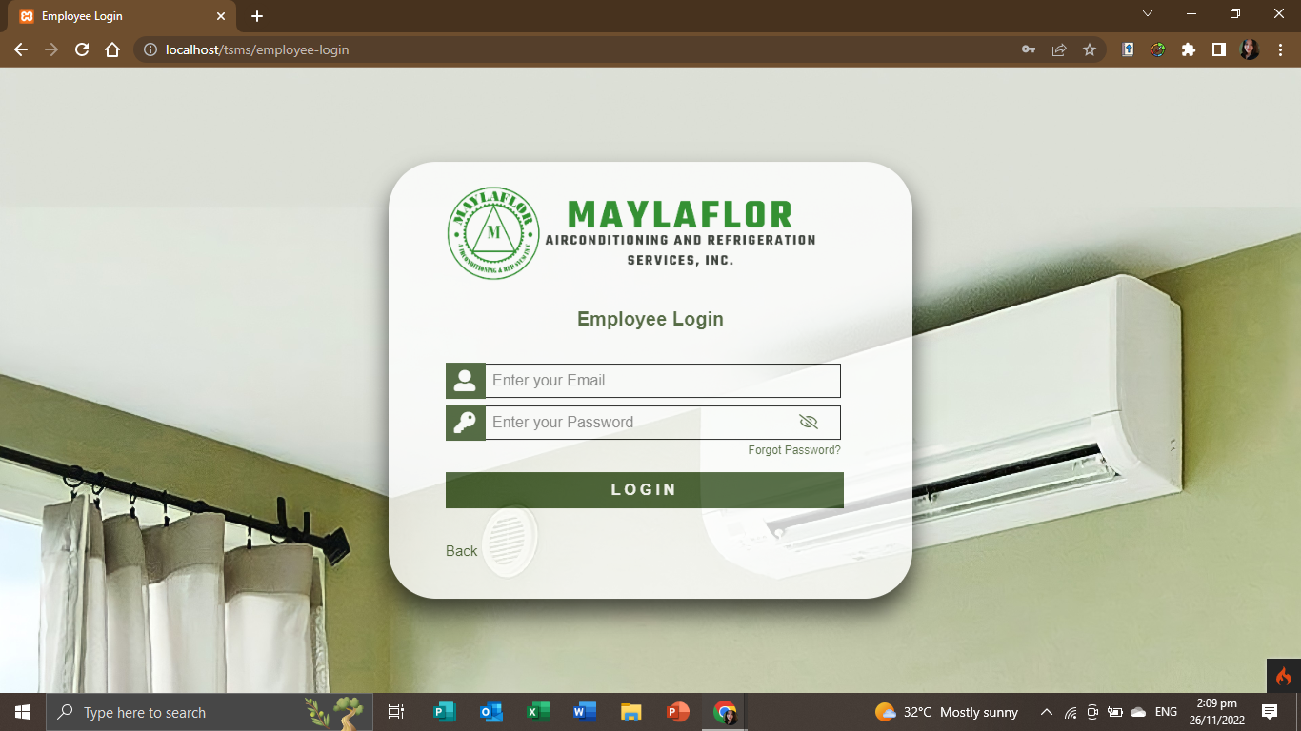**Login Page for Employee**
* **Login Page for Client (BDO/Partnered Company)** 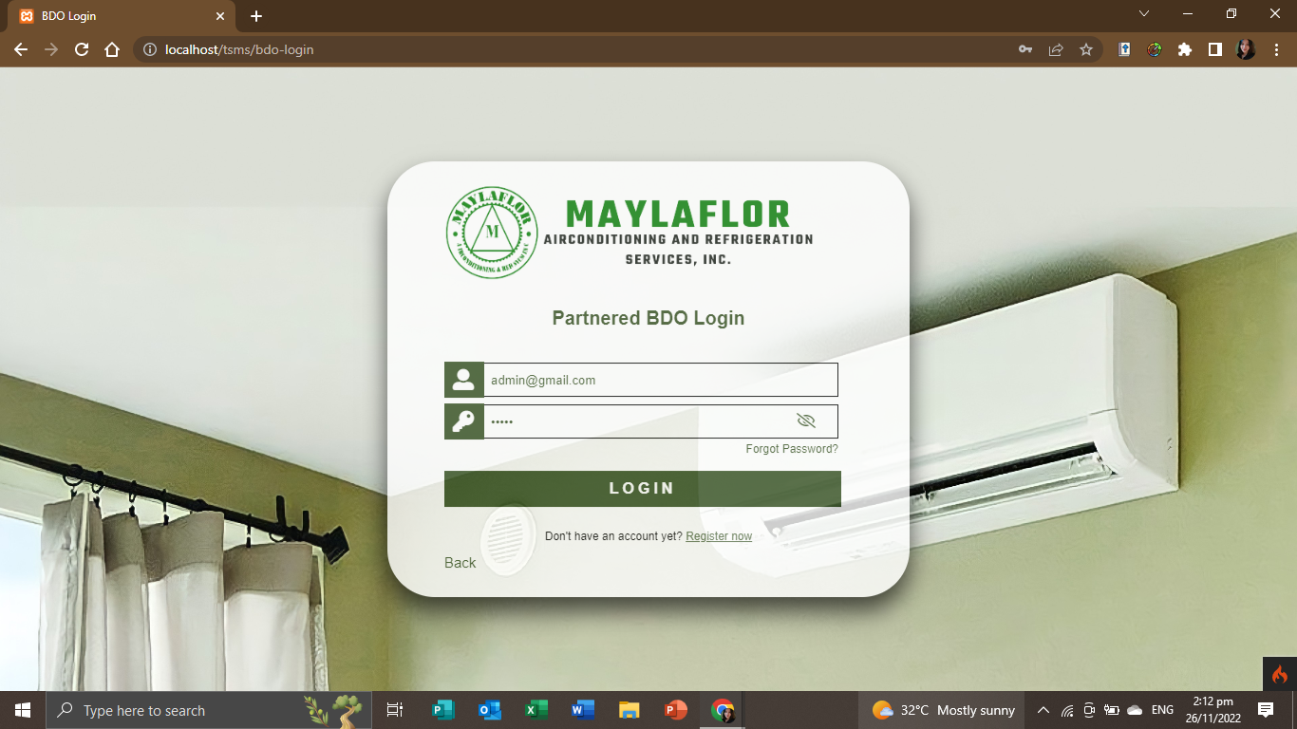
* 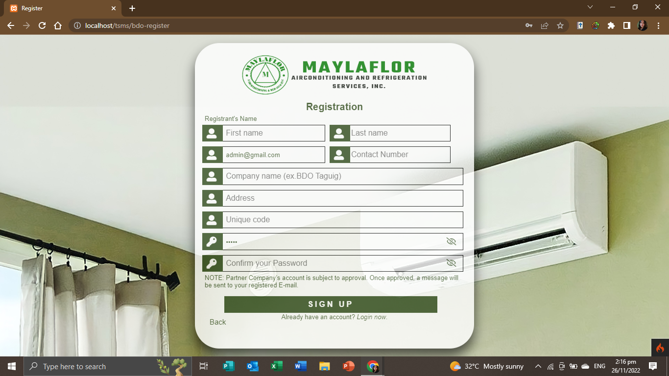**Sign-up page for Client (BDO/Partnered Company)**
* **Admin Side**
* **Dashboard:** Views the graphical representation of overall tasks including daily, weekly, monthly, pending and completed.

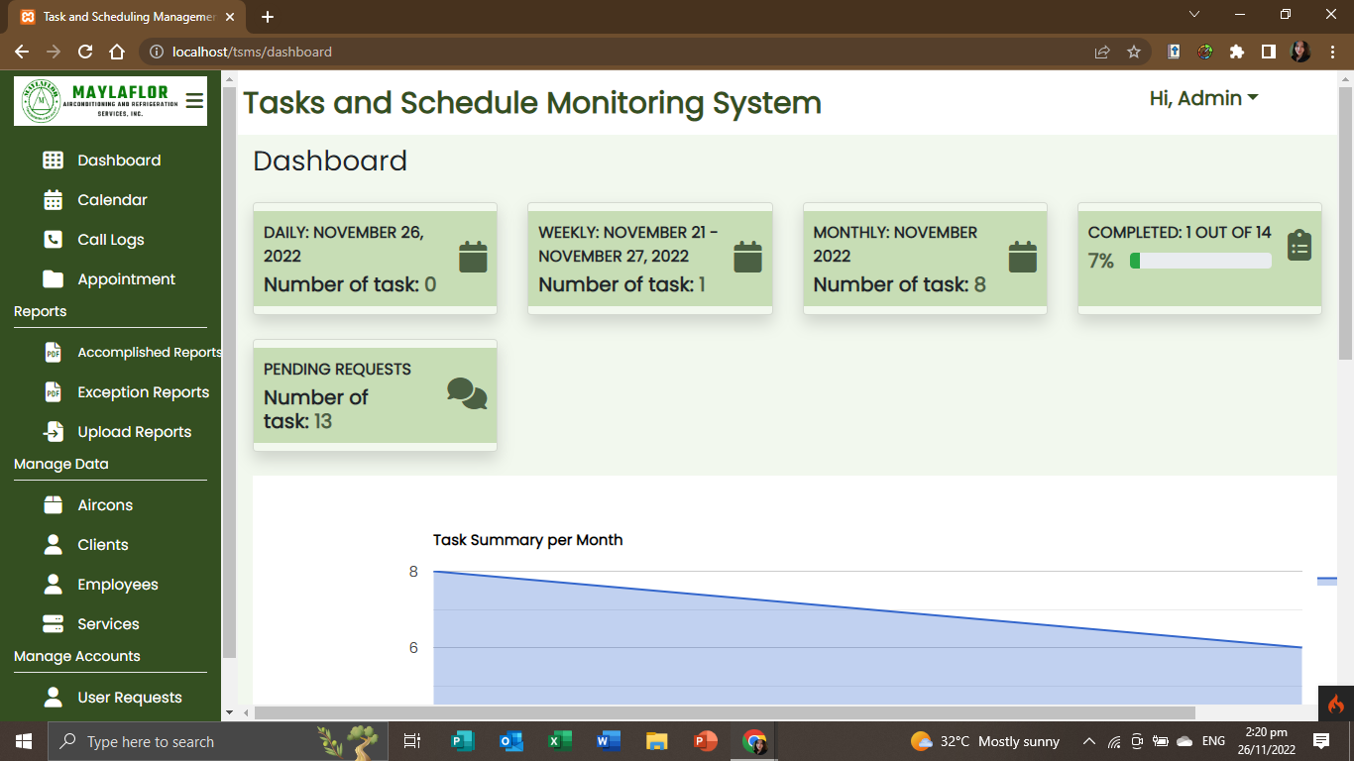

* 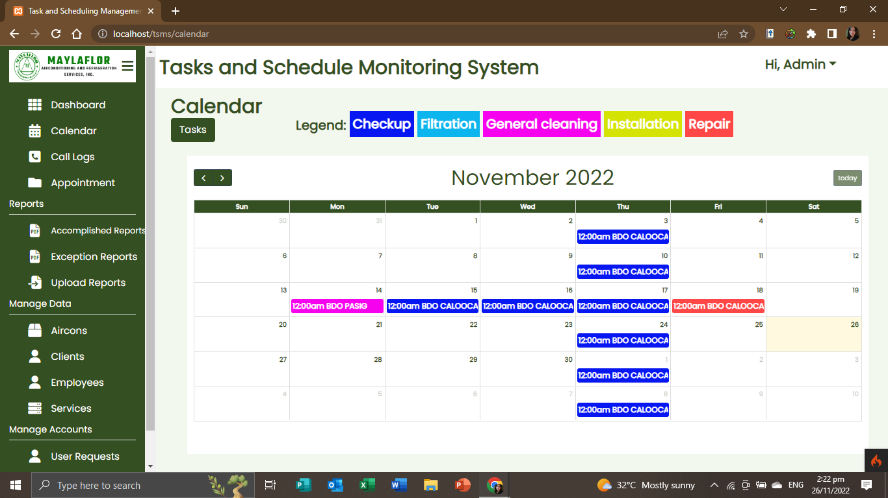**Calendar:** Contains scheduled tasks details (daily, weekly and monthly) and generates reports.
* Overall lists of schedule tasks

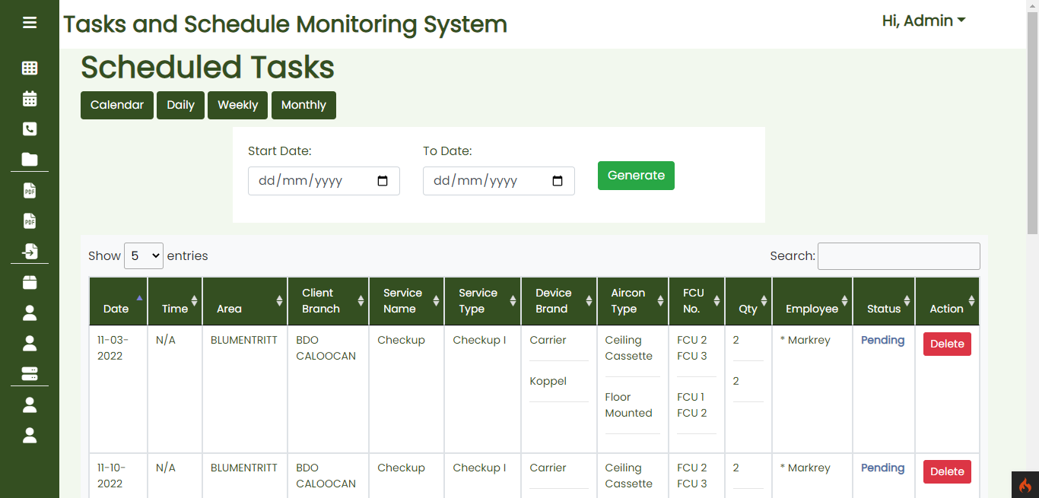

* 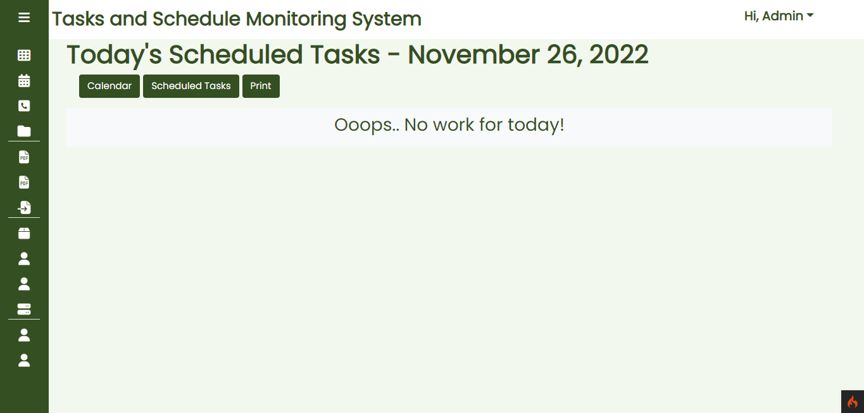Daily list of scheduled tasks
* 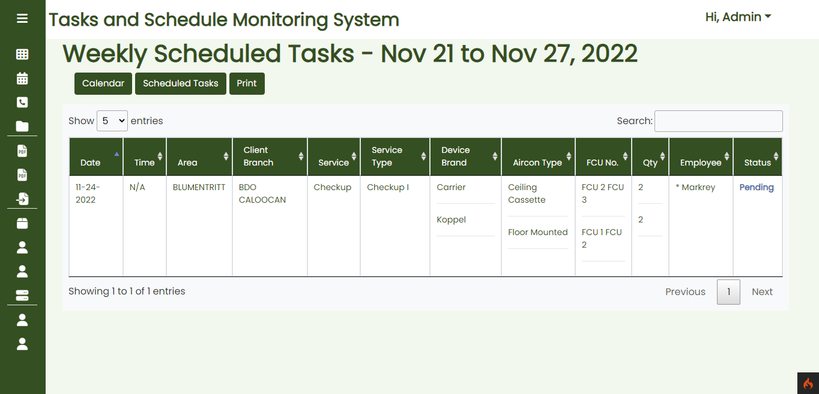Weekly list of scheduled tasks
* 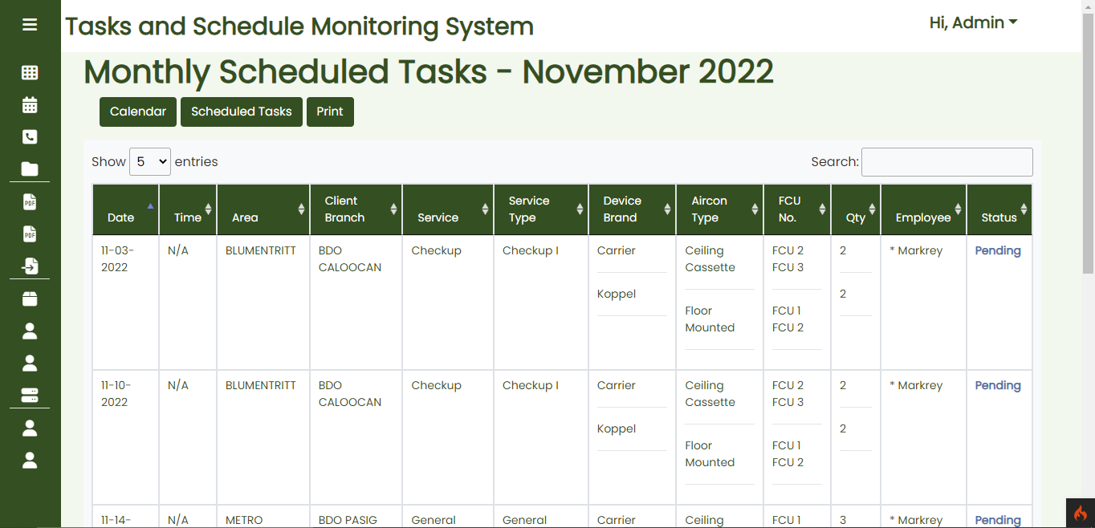Monthly list of scheduled tasks
* 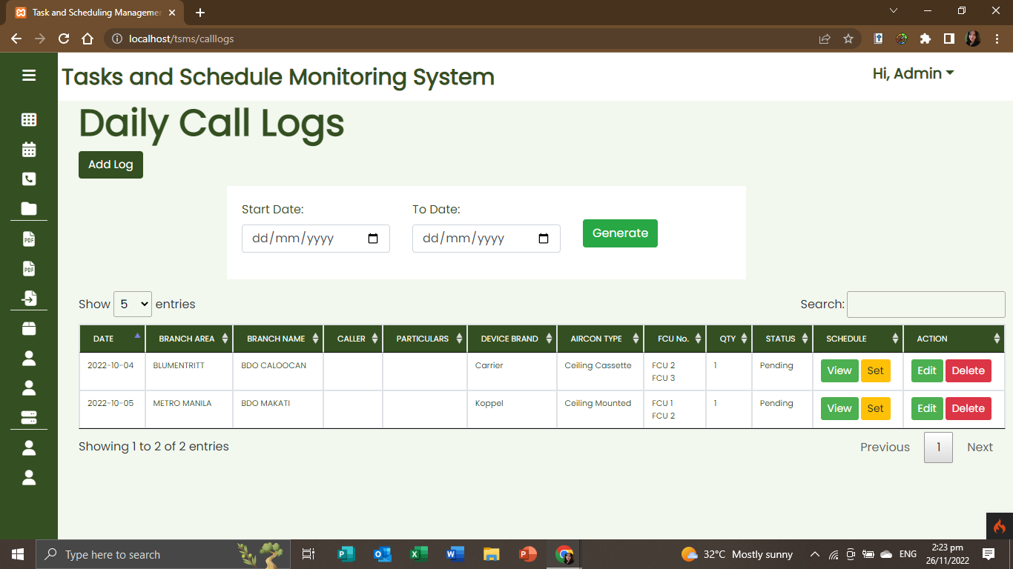**Call Logs:** Contains call log details and generates all call logs reports.
* 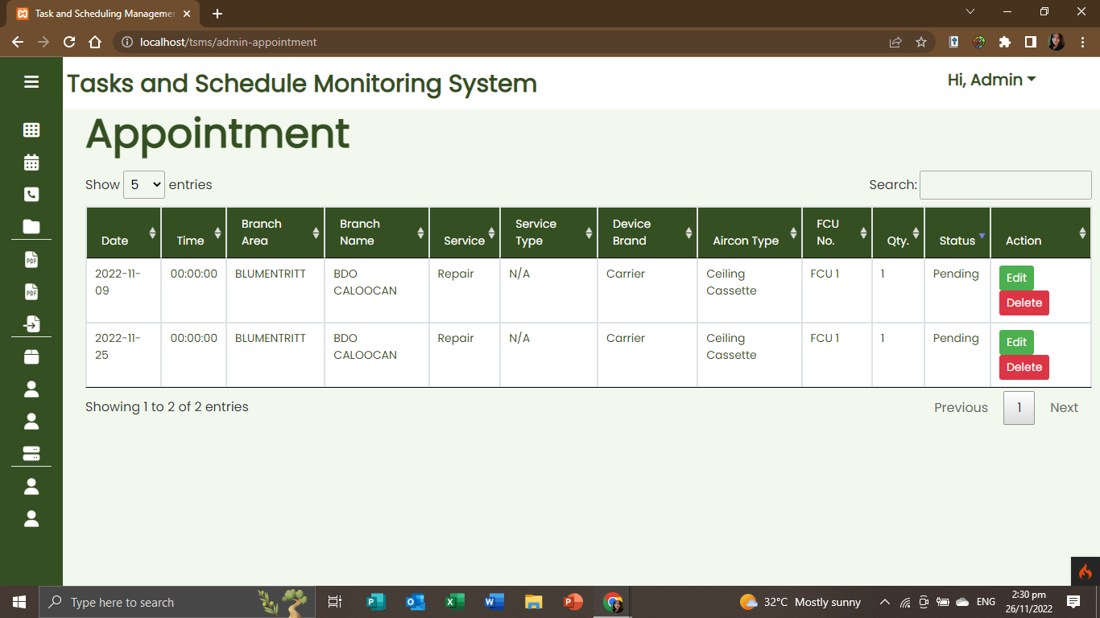**Appointments:** Contains list of appointments
* 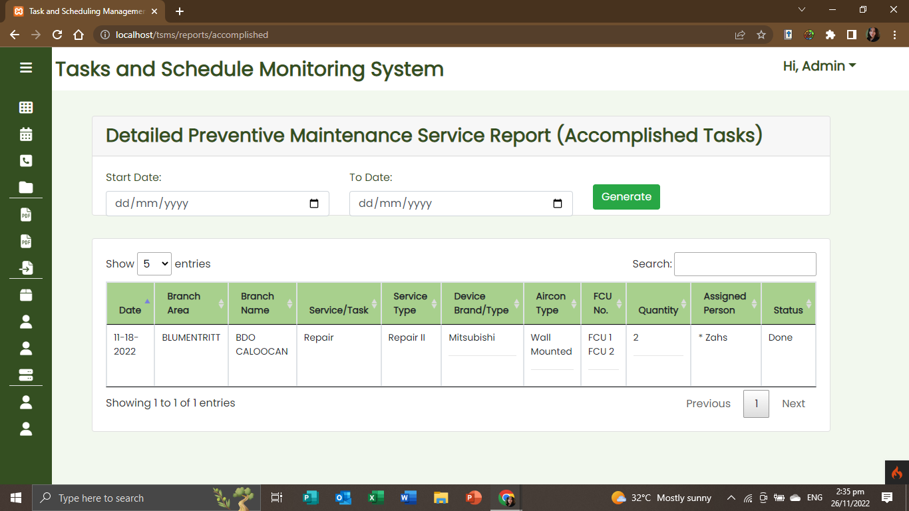**Accomplished Reports:** Contains accomplished report details and generates all accomplished reports.
* 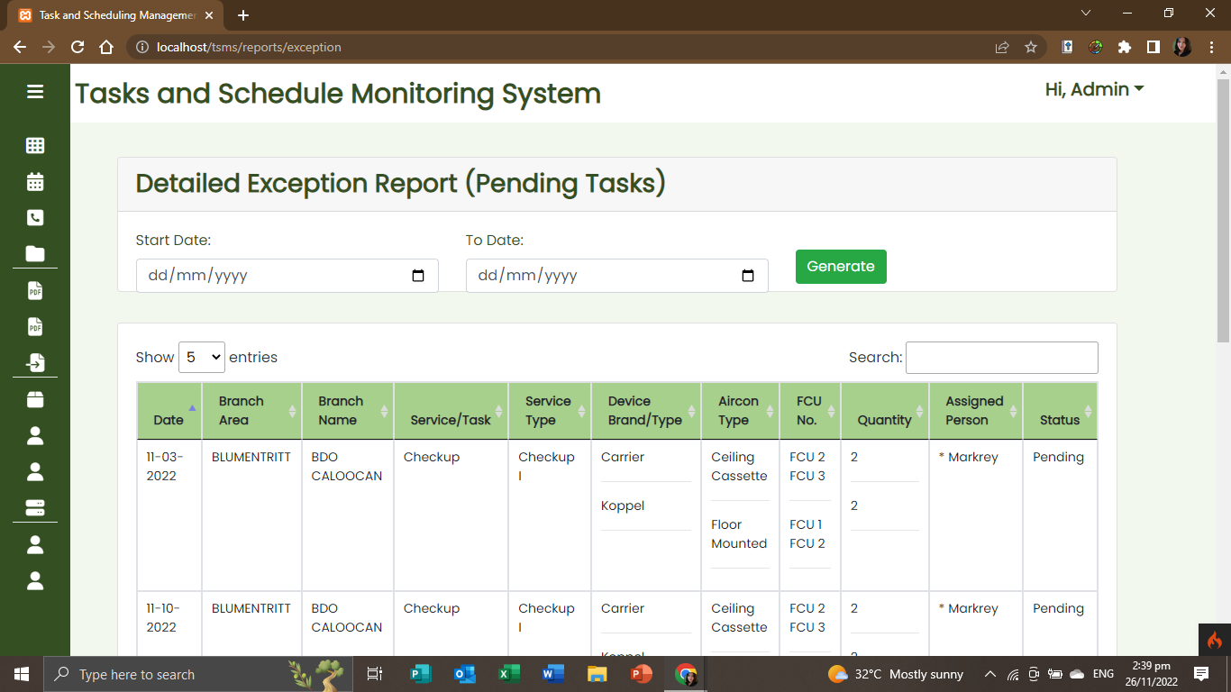**Exception Reports:** Contains exception report details and generates all exception reports.
* 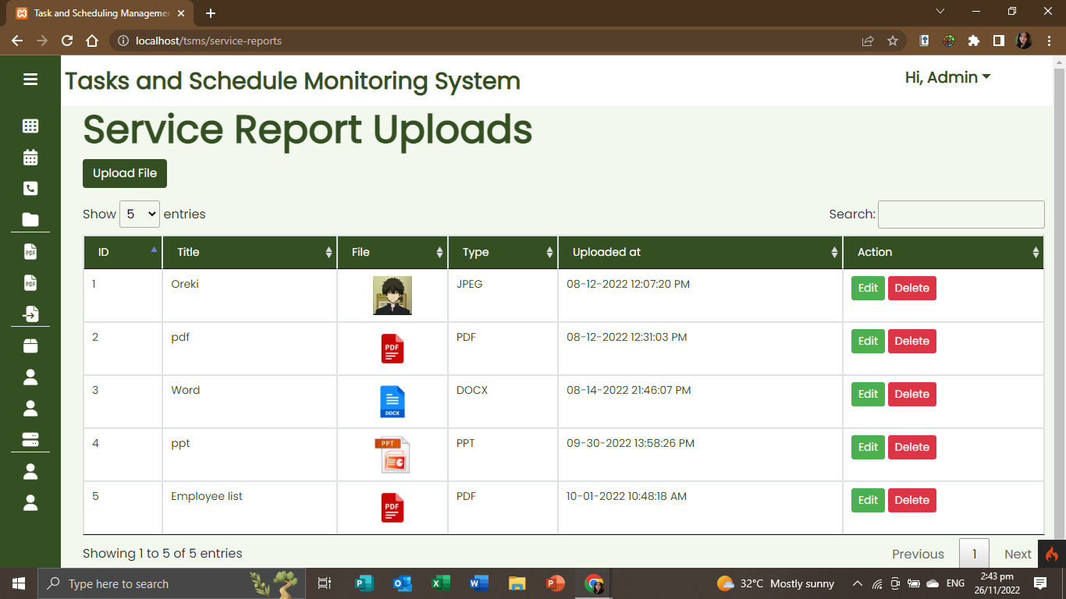**Upload Reports:** Contains list of report uploads and allows users to upload reports.

* 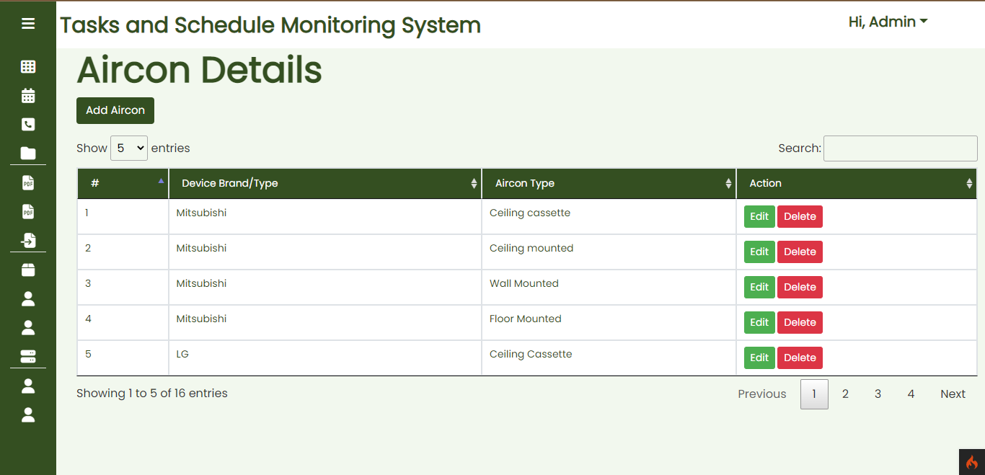**Aircon Details:** Contains lists of aircon details.
* 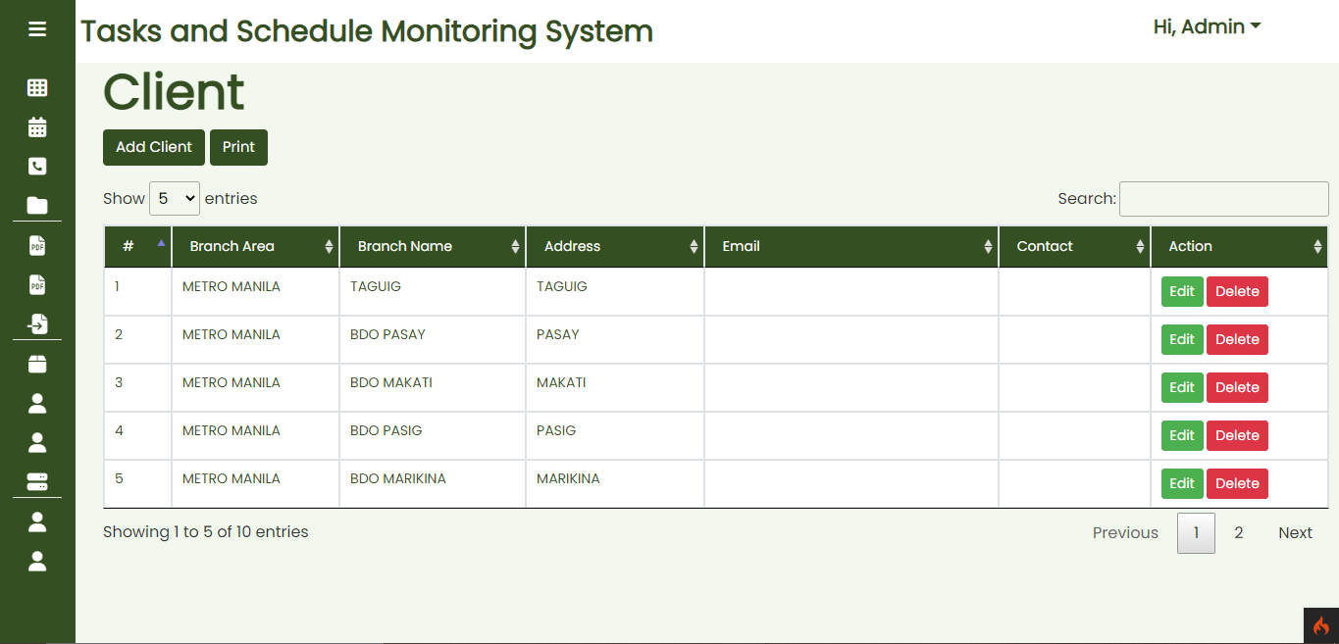**List of Clients:** Contains lists of client details and generates reports.
* 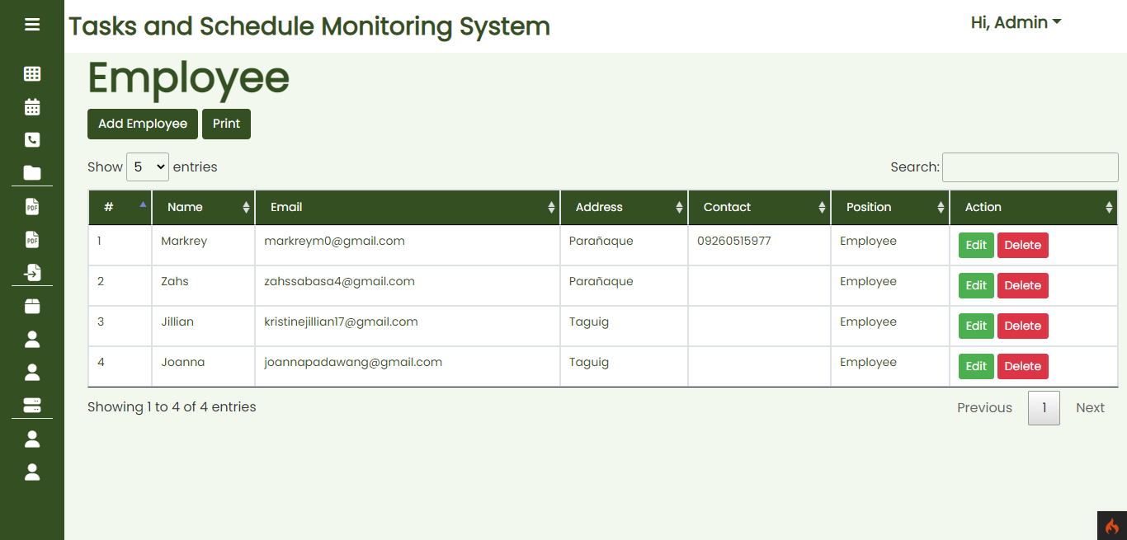**List of Employees:** Contains lists of employee details and generates reports.
* **List of Services:** Contains lists of services details and generates reports.

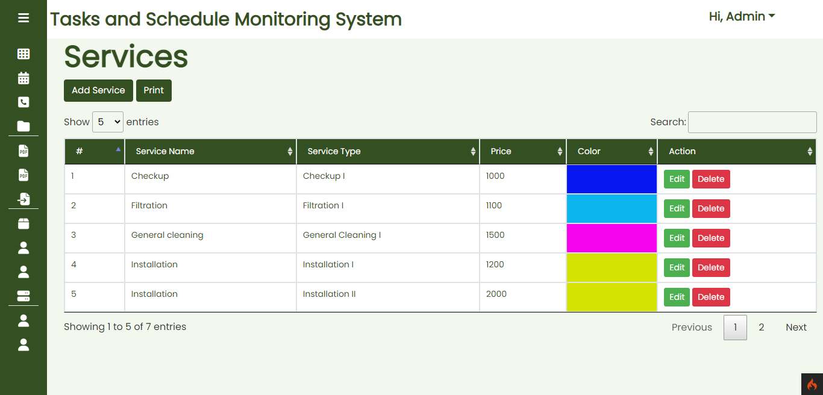

* 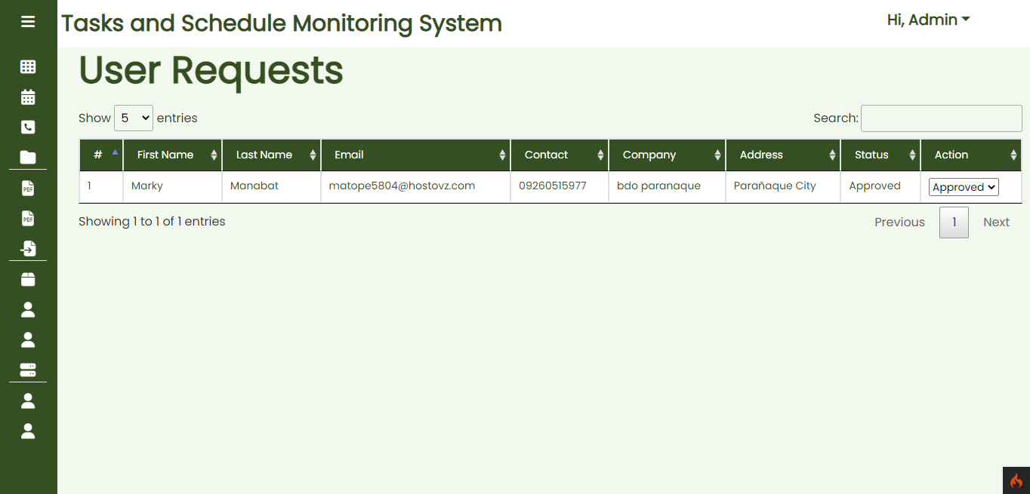**List of Users Request:** Allows the user to accept or decline accounts created by the clients.
* 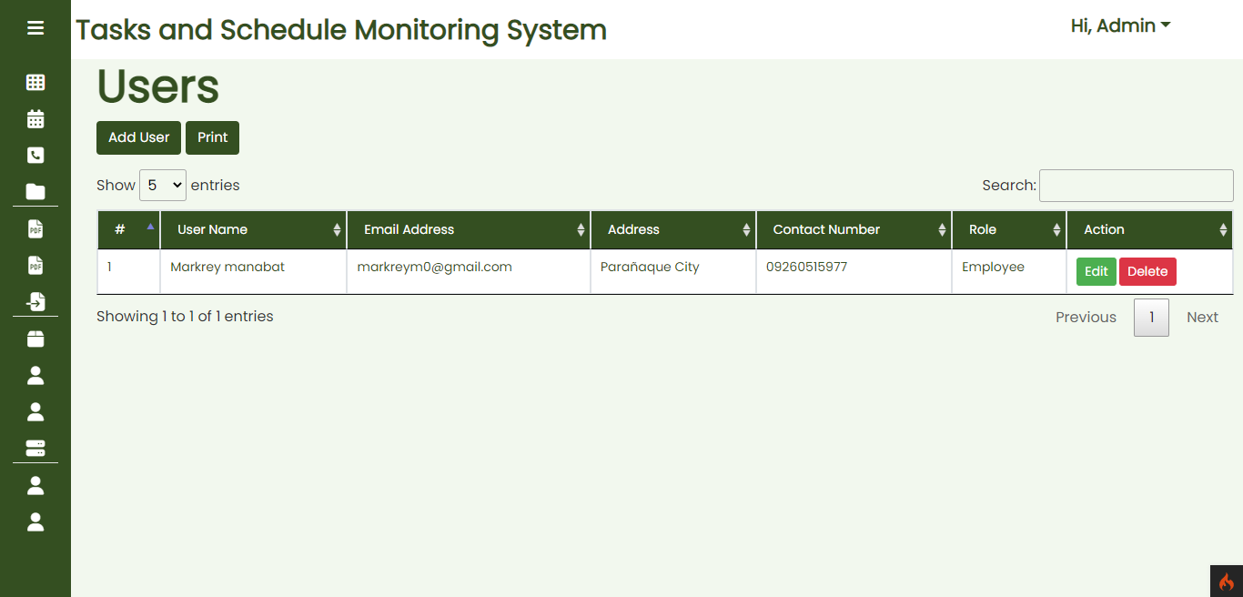**List of All Users:** Contains lists of different users.
* 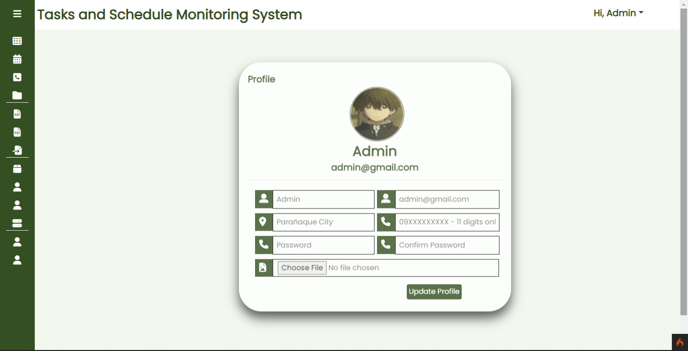**Account Settings:** Allows the user to edit the account.
* **Employee Side**
* 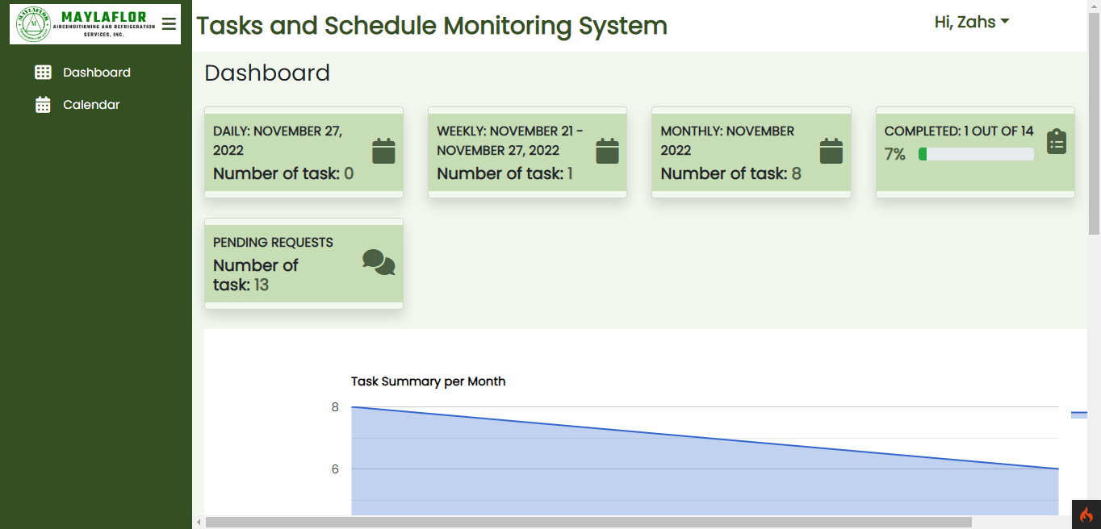**Dashboard:** Views the graphical representation of overall tasks including daily, weekly, monthly, pending and completed.
* 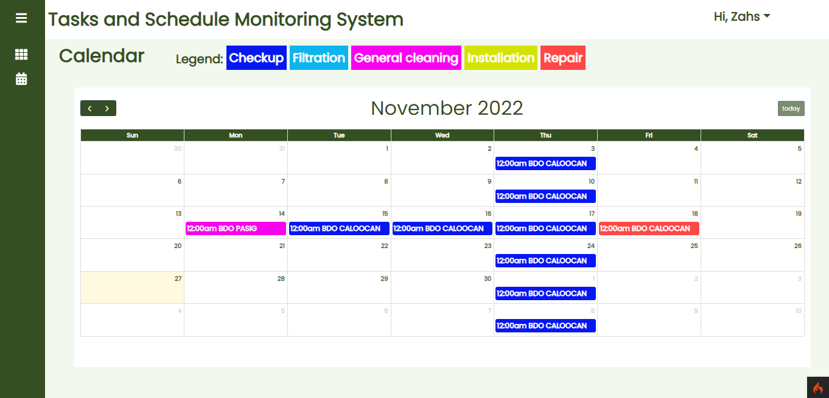**Calendar:** Contains scheduled tasks details of the account (daily, weekly and monthly)
* **Account Settings:** Allows the user to edit the account.

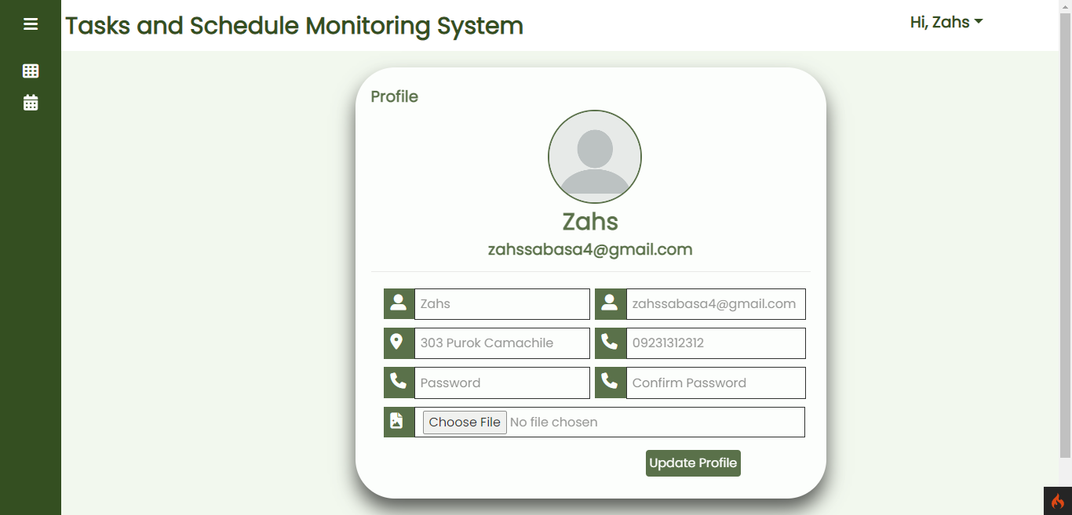

**3.3 Technical Specifications**

* 1. **Database Design**

**Entity Relationship Diagram**

**Database Dictionary**

* 1. **Screen Design**

**3.4 System Requirements**

* 1. **Hardware/Software/Peopleware**

|  |  |  |
| --- | --- | --- |
|  | **Minimum Requirements** | **Maximum Requirements** |
| Processor: | 1.8 GHz | 2.2 GHz, or above |
| Memory: | 512 MB RAM | 1GB RAM, or above |
| Storage: | 2GB free hard disk | 5 GB free hard disk space |
| Operating System: | Microsoft Windows 7 or up newer version | |
| Software/s: | Google Chrome/Microsoft Edge/Mozilla Firefox browser  MYSQL Server  Atom/Sublime/Visual Code as IDE | |
| Monitor: | 12” | |

**Peopleware**

* Administrators
* Employees
  1. **Security**

**REFERENCES**

Almeida, J. R., Gini, R., Roberto, G., Rijnbeek, P., & Oliveira, J. L. TASKA: A modular task management system to support health research studies (2019). BMC Medical Informatics and Decision Making, 19(1). https://doi.org/10.1186/s12911-019-0844-6

Arunarani, AR., Manjula, D., & Sugumaran, V. (2019). Task scheduling techniques in cloud computing: A literature survey. Future Generation Computer Systems, 91, 407–415. https://doi.org/10.1016/j.future.2018.09.014

Benmoussa, K., Laaziri, M., Khoulji, S., Larbi, K. M., & Yamami, A. E. (2019). A new model for the selection of web development frameworks: application to PHP frameworks. International Journal of Electrical and Computer Engineering (IJECE), 9(1), 695. https://doi.org/10.11591/ijece.v9i1.pp695-703

Cambridge Dictionary. (2021). web-based. Retrieved December 13, 2021, from @CambridgeWords website: https://dictionary.cambridge.org/us/dictionary/english/web-based

Chaudhari, S., Magar, N., Patil, M., & Ubale, S. (2020). IJIERT-PUBLIC REMINDER AND TASK MANAGEMENT SYSTEM. Retrieved December 11, 2021, from NOVATEUR PUBLICATIONS website:

https://www.academia.edu/43442687/IJIERT_PUBLIC_REMINDER_AND_TASK_MANAGEMENT_SYSTEM

Chiang, H. S., & Huang, T. C. (2015). User-adapted travel planning system for personalized schedule recommendation. Information Fusion, 21, 3–17. https://doi.org/10.1016/j.inffus.2013.05.011

Data. (2020). Retrieved December 12, 2021, from Techterms.com website: https://techterms.com/definition/data

Forturia, A., Natu Prihanto, J. J., & Winarno, P. (2021). Web-Based Integrated Scheduling System at Universitas Multimedia Nusantara. Conference Series, 3(1), 573-583. https://doi.org/10.34306/conferenceseries.v3i1.393

Hoang Lan Chi, & Thu, T. (2017). Some trends for innovating scientific and technological tasks management in the world. Journal SCIENCE and TECHNOLOGY POLICIES and MANAGEMENT, 6(3), 93–111. Retrieved from https://vietnamstijournal.net/index.php/JSTPM/article/view/209

Hu, X., Cui, N., Demeulemeester, E., & Bie, L. (2016). Incorporation of activity sensitivity measures into buffer management to manage project schedule risk. European Journal of Operational Research, 249(2), 717 727. https://doi.org/10.1016/j.ejor.2015.08.066

Hughes, S. E. (2018). Scheduling Using a Web-Based Calendar: How Teamup Enhances Communication. Public Services Quarterly, 14(4), 362–372. https://doi.org/10.1080/15228959.2018.1518184

Hustinawati, Himawan, A., & Latifah (2014). Performance Analysis Framework Codeigniter and CakePHP in Website Creation General Terms. International Journal of Computer Applications, 94(20), 975–8887.  
https://research.ijcaonline.org/volume94/number20/pxc3895946.pdf

Improving Laboratory Workflow Through Utilization of a Schedule Free System - ProQuest. (2018). Retrieved May 18, 2022, from Proquest.com website:

https://www.proquest.com/openview/eb12d7279fa488faa6ddd87c62ad2f86/1?pqorigsite=gscholar&cbl=586299

Intelligent task management platform for health care workers. (2017). Retrieved December 12, 2021, from Informatics for Health and Social Care website: https://www.tandfonline.com/doi/abs/10.3109/17538157.2015.1113178

IT Systems Definition: 1k Samples | Law Insider. (2021). Retrieved December 13, 2021, from Law Insider website: https://www.lawinsider.com/dictionary/it-systems

Jiakai, X., Wen, Z., & Gang, C. (2019). Design of Intelligent Personal Schedule Management System. 2019 14th International Conference on Computer Science & Education (ICCSE). https://doi.org/10.1109/iccse.2019.8845433

Köse, B. Ö., Çakici, A., Coskun, V., Kaymakçi, T., İşlek, İ., & Alsadi̇M. (2021). A Scheduling System for Enhancing and Monitoring Work Performance of Field Employees. Beykent Üniversitesi Fen ve Mühendislik Bilimleri Dergisi, 14(1), 6–14. https://doi.org/10.20854/bujse.985510

Letkowski, J. (2015). Doing database design with MySQL. Journal of Technology Research, 6, 1. https://www.researchgate.net/profile/Jerzy-

Letkowski/publication/271910489_Doing_database_design_with_MySQL/links/54dd41bf0cf282895a3b5175/Do ing-database-design-with-MySQL.pdf

Lutkevich, B., & Hughes, A. (2017). database (DB). Retrieved December 13, 2021, from

SearchDataManagementwebsite: https://searchdatamanagement.techtarget.com/definition/database

Mahmud, S. (2018). Task Management System. Retrieved from http://dspace.uiu.ac.bd/bitstream/handle/52243/185/MSCSE%20Sohana%20DSPACE.pdf?sequence=1

Meitarice, S., Mustafa, M., & Andi, D. (2021). AUTOMATED TASK MANAGEMENT SYSTEM USING ANALYTICAL HIERARCHY PROCESS. JURNAL TEKNIK INFORMATIKA. 13. 189-200. 10.15408/jti.v13i2.17037. http://journal.uinjkt.ac.id/index.php/ti/article/view/17037/pdf

Moh Sukron Mufaqih, Kaburuan, E. R., & Wang, G. Implementation gamification concept on task management system based on web (2020, January 21). from ResearchGate website: https://www.researchgate.net/publication/338718579_Implementation_gamification_concept_on_task_manage ment_system_based_on_web

Muto, Keita; Kimita, Koji; Tanaka, Hiroki; Numata, Eriko; Hosono, Shigeru; Izukura, Sayaka; Shimomura,Yoshiki. A Task Management Method for Product Service Systems Design. (2016). from Booksc.org website: https://booksc.org/book/59717181/e26387

Osman, A. S. A., & Osman, A. S. A. (2019, March). Evaluating Employee Performance using Automated Task Management System in Higher Educational Institutions. Indian Journal of Science and Technology. Retrieved May 19, 2022, from https://sciresol.s3.us-east-2.amazonaws.com/IJST/Articles/2019/Issue-9/Article9.pdf

Prokofyeva, N., & Boltunova, V. (2017). Analysis and Practical Application of PHP Frameworks in Development of Web Information Systems. Procedia Computer Science, 104, 51–56. https://doi.org/10.1016/j.procs.2017.01.059

Rahardja, U., Andriyani, F., & Triyono, T. (2020). Model Scheduling Optimization Workforce Management Marketing. Aptisi Transactions on Management (ATM), 4(2), 92–100. https://doi.org/10.33050/atm.v4i2.1259

Rincon C., C. A., & Cheng, A. M. K. (2015). Using Entropy as a Parameter to Schedule Real-Time Tasks. 2015 IEEE Real-Time Systems Symposium. https://doi.org/10.1109/rtss.2015.44

Satoto, K. I., Isnanto, R. R., Kridalukmana, R., & Martono, K. T. (2016). Optimizing MySQL database system on information systems research, publications and community service. 2016 3rd International Conference on Information Technology, Computer, and Electrical Engineering (ICITACEE). https://doi.org/10.1109/icitacee.2016.7892476

Stepanova, A., & Shilova, L. (2020). Prospects of using Task management in design. IOP Conference Series: Materials Science and Engineering, 869(6), 062037. <https://doi.org/10.1088/1757-899x/869/6/062037>

System Architecture - Detailed Explanation. (2022, June 17). Retrieved November 27, 2022, from InterviewBit website: https://www.interviewbit.com/blog/system-architecture/

Tatroe, K., & Maclntyre, P. (2020). Introduction to PHP. In Programming PHP: Creating dynamic web pages (4th ed., pp. 1-2). O'Reilly Media Inc.

https://books.google.com.ph/books?hl=en&lr=&id=kEjWDwAAQBAJ&oi=fnd&pg=PP1&dq=php+programming+language&ots=6WXwhrmSlU&sig=p_TqxdV8ZfvDokOIRo11U7WeR3g&redir_esc=y#v=onepage&q=php%20pr ogramming%20language&f=false

Technology acceptance model - EduTech Wiki. (2019). Retrieved December 13, 2021, from Unige.ch website: http://edutechwiki.unige.ch/en/Technology_acceptance_model

What is Task Management Theory? & How it Impacts The Overall Project. (2020, November 20). Retrieved December 13, 2021, from Clarizen website: https://www.clarizen.com/task-management-theory-what-youneed-to-know/